  REPORT TO | ON
CABINET  SCRUTINY | 13 February 2019  14 February 2019
September 2017
TITLE | PORTFOLIO | REPORT OF
2019/20 Budget and Medium-Term Financial Strategy 2019/20 to 2022/23 | Cabinet Member (Finance) | Deputy Chief Executive Resources & Transformation (S151 Officer)

Is this report a KEY DECISION (i.e. more than £100,000 or impacting on more than 2 Borough wards?)  Is this report on the Statutory Cabinet Forward Plan?  Is the request outside the policy and budgetary framework and therefore subject to confirmation at full Council?  Is this report confidential? | Yes  Yes  Yes  No

- PURPOSE OF THE REPORT

  - The purpose of this report is to set out the proposed 2019/20 Revenue Budget for the Council and the Medium Term Financial Strategy for the next 4 years. This is the financial plan for the Council for the next 4 years. It is aligned to the Corporate Plan and how the Council will deliver its ambitions and services for residents. Cabinet approval is sought and recommendation to Council on 27th February 2019.

- PORTFOLIO RECOMMENDATIONS

  - That Cabinet recommend for approval the 2019/20 Budget and Medium Term Financial Plan 2019/20 to 2022/23 to Full Council on the 27th February 2019

  - Cabinet approve the Revised Estimate for 2018/19 as set out in Appendix A

  - Cabinet approve the Revenue Budget for 2019/20 and the 4 year Medium Term Financial Strategy (MTFS) 2019/20 through to 2022/23, summarised at Appendix B.

  - Cabinet approve the Corporate Asset Management Plan attached as Appendix D

  - Cabinet approve the Capital & Investment Strategy attached as Appendix E

  - Cabinet approve the Capital Programme 2019/20 to 2022/23 attached as Appendix F

  - Cabinet approve the Treasury Management Policy Statement attached as Appendix G

  - Cabinet recommend to Council a Council Tax increase of 1.99%.

- CORPORATE PRIORITIES

The budget report along with the Medium Term Financial Strategy and its supporting documents allocate resources aligned to the following priorities outlined in the corporate plan:

Excellence and Financial Sustainability | X
Health and Wellbeing | X
Place | X

Projects relating to People in the Corporate Plan:

People | X

- CONTEXT FOR 2019/20 BUDGET AND MTFS To 2022/23

  - 2018/19 Budget and Medium Term Financial Strategy

The budget for 2018/19 and a five year Medium Term Financial Strategy (MTFS) agreed at Council on 28th of February 2018 set out some challenges to deliver a balanced, sustainable budget in the medium term. Assumptions were made about future levels of income from business rates, Council Tax increases, targets were set to generate savings from efficiencies and from proposals to deliver new sources of income to deliver a balanced position over five years. These totalled £5.5m over five years. Implementation has been progressed during the year. These savings have been included in the base forecasts in the budget proposal before Members.

  - Projected Outturn 2018/19

Budget monitoring is reviewed by Scrutiny Committee and Cabinet throughout the year. This enables some base budget review during the year to reflect changes to service delivery and take up. These changes have been reviewed during the budget process and reflected in the base budget. It is anticipated at the end of quarter three the Council will have a small surplus subject to year-end accounting adjustments for pensions, provisions and any impacts relating to Brexit such as property valuations.

  - Funding of Local Government

    - Major changes to local government finance started in 2013/14. These changes saw the withdrawal of central government grant to support local spending and the introduction of retaining business rates collected locally. 2017/18 was the final year that South Ribble received Revenue Support Grant (RSG) from Central Government. This was fully explained in the previous MTFS.

    - Business Rate Retention (BRR) and the Lancashire Pooling arrangements have been established since 2013/14. In essence this scheme allows increases in business rates to be retained locally. The Local Government Finance Settlement 2018/19 identified the Secretary of State’s intention to increase business rate retention as a means of funding over the next few years. A new pilot scheme has been announced to look at different arrangements for retention and pooling. The Lancashire Pool is a successful example and will feed into any future review of the arrangements. The pooling and local retention of growth arrangements continue to demonstrate benefit to South Ribble and contribute positively to the Council’s financial position. A key factor is that the Council will benefit significantly from the growth in business rates collected. Future growth will further enhance our retention in the future subject to the delivery of some major developments such as Cuerden and the Enterprise Zone. There is a small increase in BRR in the 2019/20 budget which exceeds the expectations of the previous MTFS due to the success of the Lancashire wide bid for the 75% pilot pool.

    - The Local Government Settlement for 2018/19 specifically stated the Secretary of State’s intention to reset the business rates retention system in 2020/21. This will see NNDR Baselines adjusted to reflect how much local authorities are actually collecting in business rates. The implications of this are impossible to assess at this stage. However, any changes will have transitional arrangements and South Ribble should be protected by the future growth elements that are still to come forward. This is also the justification to continue to maintain a Business Rate Retention Equalisation Reserve to allow for any significant movements in forecasts and allow time to adjust future spending.

    - New Homes Bonus scheme was established to pass the “benefits” of generating net increases in housing supply to local authorities. Changes were announced for 2017/18 to change the benefit from 6 years to 4 years. Moreover locally South Ribble Borough Council has committed to pay its receipts into City Deal. This adjustment impacts the core funding for City Deal by removing 1/3rd of the funding growth available from new housing developments. The impact also means this funding stream will cease to support South Ribble services directly in 2020/21.

    - Council tax remains the major source of funding for local services. Councils can determine the levels of taxation for their local areas but there are limitations imposed by Government regulation. The Secretary of State sets out thresholds annually for each tier of local government above which council tax increases would be deemed excessive. For district councils, increases of less than 3% or up to and including £5 (whichever is higher) above the authority’s relevant basic amount of council tax for 2018/19 can be made without triggering a referendum. A proposal for increase is included in this paper as a specific recommendation.

    - The balance of the budget and longer term Medium Term Financial Strategy is contribution to and from reserves. The pooling pilot and the removal of negative RSG are balanced off against any potential impacts of the wider Fair Funding formula review.

  - Growth

    - South Ribble is embracing the growth agenda fully. Its Local Plan identifies commercial and employment growth as well as the associated housing numbers. The Council is a major partner in Central Lancashire City Deal. As such the Council has committed investment of future funding into the programme but will see long term increases to its business rate and council tax receipts subject to the growth being delivered.

    - Growth and a population expansion will also bring with it some additional costs and demands upon our services. Our Corporate Plan does and will continue to identify projects to meet these demands. This MTFS and the Capital Investment Strategy identify the financial resources for the next 4 years to deliver on those ambitions.

  - Corporate Plan

The Council has developed a 5 year Corporate Plan that sets out its priorities for the future years and outcomes that it intends to achieve. This reflects the resident survey, consultation with stakeholders and Member input. The emerging priorities continue to be:

- Financial Excellence and Stability
- Health, Leisure & Well Being
- Place

This budget, MTFS, Capital Strategy and Capital Programme and have been aligned to these priorities. Future decisions and spending proposals are linked directly to these priorities.

  - Capital Strategy 2019/20 to 2022/23

A 4 year Capital Strategy attached has also been developed and linked to the Corporate Plan. Mindful of the future growth of the population, the health of the existing population and the ageing council leisure asset stock, the Council has developed a Health, Leisure and Wellbeing agenda which encompasses the Green Links and Campus Programme for South Ribble. That proposal requires significant investment to deliver the desired outcomes. The 4 year Capital Strategy and Programme identifies potential funding to make a significant impact to that agenda. If agreed then this requires the council to borrow to deliver. During the development period the Council will seek to secure additional third party funding to mitigate the borrowing costs. This investment will also deliver long term financial efficiencies with wider health and wellbeing benefits.

The Council will also support housing and economic growth through the use of its capital investments. These will be appraised to deliver economic outputs as well as longer term financial benefits such as invest to save and invest to earn producing either budget efficiencies or new income streams. Housing investment will seek to support requirements to supply age related, tenure and demand led initiatives.

  - Medium Term Financial Strategy

The proposed MTFS brings together the budget proposals for 2019/20 identified below that reflect Council decisions and future recommendations into a 4 year financial plan. Prudent assumptions on future growth and spending are incorporated into that plan as well as potential future changes to service delivery. This is specifically covered in section 7 below.

  - Robustness of Estimates

Under Section 25 of the Local Government Act 2003, the Authority’s Chief Finance Officer, the Deputy Chief Executive Resources and Transformation, is required to report on the robustness of the estimates made for the purposes of the Council’s annual budget. This will also extend to the assumptions contained in the Council’s Medium Term Financial Strategy (MTFS) and the financing and resourcing assumptions set out in the approved Capital Programme.

Section 25 (2) of the 2003 Act requires the Council to have regard to this report in approving the annual budget and setting the council tax.

In order to provide assurances that the budget estimates are robust the Chief Finance Officer has had regard to the following factors:
- The available resources (support from central government and locally raised income)
- The deliverability and sustainability of the budget decisions to be taken in the proposed budget
- The anticipated budget pressures arising from demand-led services
- The forecast impact of inflation anticipated pay awards and pay restructure
- Progress in delivering previous budget decisions and the anticipated outturn for 2018/19.
- The financial standing of the Council and the effectiveness of the financial management arrangements in place
- The affordability and sustainability of the capital expenditure and investment plans arising from the Council’s Capital Programme.
- The management of risk on an ongoing basis

In order to provide that reasonable assurance the Chief Finance Officer has had regard to a number of factors as part of the budget planning process which are highlighted in Appendix C to this report. Other assumptions are included in the body of the report.

- 2019/20 BUDGET

  - The table in Appendix B sets out the proposed budget for 2019/20 and the Medium Term Financial Strategy for 2019/20 to 2022/23. It is based upon a fully costed structure that is in place, existing service delivery arrangements and standards, generated efficiencies future committed contractual arrangements and income generated from services. The impact of decisions made and implemented in 2018/19 have been included.

  - Revised Base Budget Requirement

This section focuses on 2019/20 budget specifically. It sets out to identify the specific decisions required of Cabinet and Council. It will also explain the major elements and changes from the current MTFS approved for 2018/19. These encompass
- Changes in the government funding formula to remove negative Revenue Support Grant (RSG) for 2019/20 only
- The impact of the Lancashire County business rates pooling for 2019/20 only
- The full impact of the green waste collection
- A revised income profile from the commercial property investment
- A revised income forecast for Council Tax and Business Rates that reflects planning applications approved
- A level of transformation approved and delivered.
- Anticipated benefits arising from the Capital Programme based on invest to save / earn principles.
- Levels of inflation and contract growth
- Agreed NJC pay adjustments

The additional costs and income have an on-going impact on future years. The impact has been incorporated into the Medium Term Financial Strategy which is shown in Appendix B and discussed later in section 7.

  - MTFS Decisions to be Implemented

The senior management restructure was agreed and the recruitment processes have been completed and the Leadership Team are now fully in place. Given the changes in the government funding formulas other than the proposed Council Tax increase there are no significant decision to be made regarding the setting of the 2019/20 budget. The 2019/20 Council Tax Support Scheme was recommended to Full Council on the 23rd January 2019

Ongoing the council is seeking through its MTFS to improve its net return from its asset base both in the form of cash balances and property. Consultants have been appointed to oversee a property investment fund and the Council will be undertaking an asset database review for future investment opportunity or income generation. Officers will continue to identify efficiency savings in operational budgets. Some of these many require upfront capital investment with invest to save / earn benefits. Additional reports will be presented to Cabinet as required if decisions are to be made

  - Funding

    - Retained Business Rates is based upon the NNDR 1 return. Here there is shift from the previous MTFS assumptions. That predicted a base level of £4.293m after a transfer of £0.304m into the Business Rate Reserve and potential growth from 2020/21 of £0.25m. The retained business rates in the proposal is £5.700m. The increase in 2019/20 is significant and largely due to the success of the Lancashire-wide bid for a 75% share of BR growth, plus the forecast collection fund surplus from 2018/19 distributed in 2019/20 and an overall increase in the rateable values. This reflects the Council’s commitment to pay over its retained business rate commitments within the City Deal arrangements or through the Enterprise Zone.

    - The 2019/20 Council Tax figure represents the current rate of collection and revised council tax base. It includes the current estimated surplus of £98,000 on the Council Tax Collection Fund.

  - 2019/20 Budget Proposals

Investment in Corporate Priorities

    - The base line budget proposals have been aligned with the Community Strategy and Corporate Plan to give the Council the capacity to deliver on these priorities. Funds approved in last year’s budget have been continued to maintain the progress in those initiatives.

    - In addition the staffing structure has been reviewed to formalise a number of prior arrangements relating to honoraria, temporary and interim posts. As South Ribble will see major growth in the coming years small amounts of additional resources have been built in to increase capacity to deliver the projects proposed in the capital programme and externally funded projects.

    - The Council will continue to seek out additional funding sources to bolster its delivery programme and offset future revenue or capital borrowing requirements

  - Capital Strategy

The detailed Capital and Investment Strategy attached as Appendix E sets out the 4 year investment plan and the consequences of borrowing to meet some of the investment are built into the base budget along with the anticipated returns on a spend to save basis.

  - Transformation Savings

Known savings from the Transformation Programme has been included in the 2019/20 budget. This is the forecast savings from the 1st phase of transformation and are focussed in the following areas:

- Depot Commercialisation
  - Additional space utilisation by third party contractors
  - Spend to save energy efficiency
  - Shared fuel supply arrangements
  - Vehicle rationalisation
- ICT Review
  - Review of systems and costs across all directorates
- Gateway Review
- Corporate review of neighbourhood working
- Green Waste collection – reducing waste to land fill and more efficient collection
- Improved environmental services delivery. Grounds staff to undertake S106 funded works over the winter periods on green links projects.

Work has commenced on projects that can deliver greater efficiencies across the Council through its blended working across all directorates, for example a new Digital Strategy. Some of these projects will require upfront investment on the basis of invest to save or invest to earn principles. This has been included in the base budget funded from a Transformation Reserve established in previous financial year.

  - Council tax increase

The Council has the ability to increase council tax levels to fund on-going expenditure. Options to increase Band D council tax have been considered. These options and the level of additional income generated are shown in Table 1 below.

Table 1 Potential Income from Council Tax Increases

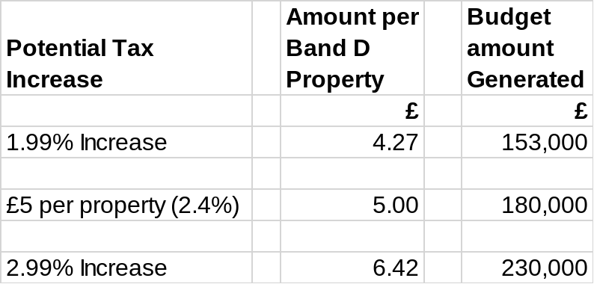

The proposal before Members includes an increase of 1.99% generating £153,000 of additional revenue amounting to 8p per week per average household for South Ribble services. Cabinet is asked to recommend this increase to Council on 27th February 2019.

- MEDIUM TERM FINANCIAL STRATEGY (MTFS)

  - The Medium Term Financial Strategy (MTFS) is shown in Appendix B. This reflects the impact of investing in the Corporate Plan over the next 4 years. It takes on the full year impact of 2018/19 budget decisions and further assumptions have been made. This section outlines what those assumptions are and how they impact on the overall financial strategy.

  - Pension Fund Triennial Review
The pension fund is revalued every three years and contributions adjusted based upon the actuary’s opinion of value and liabilities. The Council currently make lump sum payments to the fund for the current three year period. The next revaluation takes place in 2019/20 and will include a balancing of the previous three years payments. Invariably this may result in an increase in local authority contributions. An estimate of a 2% increase has been included in the MTFS from 2020/21 to reflect potential changes.

  - Fees & Charges
Increases in general fees and charges have not been assumed unless required for statutory purposes for cost recovery or set by other bodies. Charges will continue to be reviewed and further decisions brought to Cabinet if required.

  - Property Investment

The Council continues to seek out wider property investment opportunities which reflects the Council’s current ambition to deliver housing and economic growth. Professional advisors have been appointed to seek out external property investment opportunities. The Council will further seek other investments that generate returns which may include housing and employment growth. The Council’s Treasury Management Policy statement attached as appendix G fully reflects current best practice and will underpin each business decision that is brought forward. The Council will also seek to review its own property asset database to provide future investment and or additional income.

  - Transformation and Shared Services Savings

The Council continues to review all of its services seeking out opportunity for transformational changes and investment opportunities that generate efficiencies, new income or improved service delivery.

A review of the current and future shared service agreement is being undertaken and will report back in June 2019. Efficiencies in proposed operations will be included in future reports.

  - Capital and Investment Strategy

The Capital and Investment Strategy attached as appendix E sets out a 4 year investment programme of £41.4m to deliver significant improvements to services for residents of the Borough. To deliver this ambitious programme it is anticipated borrowing of £20.6m will be undertaken. However, the investment and borrowing in the Health, Leisure and Well Being programme will deliver efficiencies and additional income which were highlighted to Members in previous reports.

  - Business Rates

    - Business Rate retention brings with it many advantages including keeping a share of the benefits of growth locally. However, there are also some potential risks because negative changes to business rate levels such as business closures or empty rates needs to be met locally. Therefore the Council has established a Business Rate Retention Reserve.

    - Part of this reserve has now been identified for City Deal specific payments. The Council is committed to certain levels of payments based upon business rate growth over the next few years. Also the Council will need to incur additional expenditure to deliver that growth. This reserve will help meet some of those commitments.

    - The retained business rate level within the MTFS is based on the January 2019 NNDR1 return. Assumptions have been made for inflation and an element of growth. There is an element of risk that growth is impacted by external factors such as developments coming forward and wider economic factors such as Brexit.

    - Part of the benefits of retaining business rates is that the increases in rates level generated from growth are kept locally. The MTFS shows a prudent view of the net benefits coming into the Council’s financial strategy in 2019/20 and increasing the following year.

  - Council Tax

The MTFS assumes a continuation of Council tax rises at 1.99% for the current and future years based on current arrangements continuing. This decision will be reviewed each year as Council must determine the level of Council Tax each year as a formal, statutory decision as a billing authority. This gives the mandate for billing each household.

The MTFS assumes a rate of growth supported by the City Deal proposals and the ongoing monitoring of new housing completions.

  - New Homes Bonus

The monies identified as New Homes Bonus (NHB) are currently passorted to the County Council as funding support to the City Deal. Following changes to legislation the amounts received reduced from six annual sums to four. The budget identifies those sums approved. It is anticipated that NHB will be subject to the Fair Funding changes proposed in 2020/21.

  - Use of General Fund Balances

The proposed MTFS recommends using the general fund surplus to increase the Council Capital Investment reserve. This enables a transition to a medium term balanced budget position with the opportunity to invest reserves into future income generating, cost efficiency or mitigate future borrowing requirments.. Other options to balance the budget could include significant increasing fees and charges, higher Council Tax increase or reducing levels or quality of services. These have been considered and discounted in favour of protecting frontline services, maintaining current fees and charges and providing the resources to deliver the Councils growth, Health, Leisure and Wellbeing agenda

- BREXIT AND ECONOMIC CHALLENGES

The Council awaits the outcome fo the Brexit decision due to come into effect from the 29th of March after the Council has set its budget. The Council has already discussed this issue with its external auditors and taken consideration on a number of potential impacts. In addition the Council is also represented at Senior Officer level on the Lancashire Resilience Forum which is currently considering both county wide and local issues.

The Chief Financial Officer has considered issues that may arise following Brexit. Key issues for South Ribble are amongst others:-
- Potential for community unrest
- Energy and fuel supplies
- Property and investment values and returns
- Impact on Business rates if companies relocate

Given the level of reserves identified in the point below the Council are of the opinion that any short term impacts can be retained in the base budget and cash reserves.

The Council also need to consider the positive impacts of Brexit and the wider growth agenda. Working with land owners, partners and funders there are opportunities to grow the economy and local housing stock with the appropriate returns to the Council

- RESERVES

  - The Council had £29.8m of reserves on its balance sheet as at 31st March 2018. These are made up of general fund balance, earmarked reserves which are funds set aside for specific purposes historically, carry forward reserves from surplus income and under spending in previous years, business rate reserve, capital receipts and funds for specific purposes such as section 106 for affordable housing. A strategic review of the categorisation of these reserves has been undertaken during the budget process prompted by the focus of the financial strategy of the Council to the new Corporate Plan.

  - The overall strategy will see the Council utilising a major element of its reserves in future years to deliver the major investments required. The impact of this investment is shown on the overall reserve levels in table 2 below. Anticipated returns from these investments have been estimated in the MTFS

Table 2 Projected Reserves over the life of the MTFS

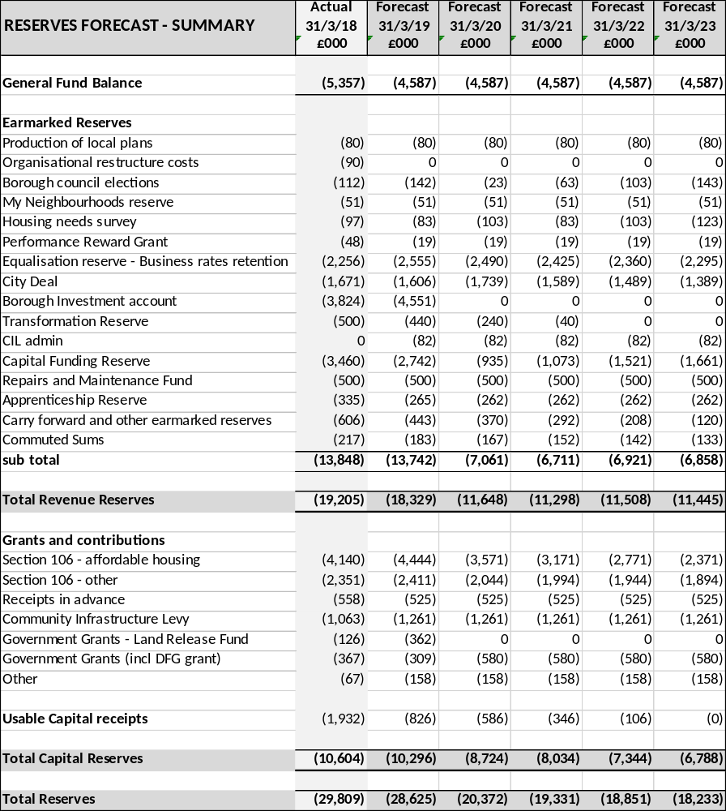

  - There is a statutory requirement within the Local Government Act 2003 for billing authorities such as South Ribble to have regard for the level of balances required for future needs when calculating its budget requirement. A prudent level for General Fund Reserve is between £4m and £5m for an authority with a net budget requirement of £15m. This should cover any unforeseen emergency funding challenges.

  - The Council is increasingly reliant on retained business rates as a source of income. The system has now been in place for 6 years and some confidence can be attached to the future receipts. This is particularly the case in South Ribble because of the Central Lancashire City Deal. Real growth in business rates is anticipated to be delivered by 2021/22. There is still the need to maintain a Business Retention Reserve to protect the Council from future fluctuations but it is probably at the right level now. Part of the fund has been allocated specifically for City Deal liabilities. This will help meet the Council’s future commitments and protect the revenue budget from any unforeseen fluctuations.

  - Reducing the level of reserves will reduce the level of investment interest that the Council will receive year on year. However, returns are extremely modest at around 0.66% so the overall impact has been absorbed into the MTFS.

  - The overall level of reserves at the end of the MTFS period remains substantial. General Fund balance is predicted to be £4.6m and other revenue reserves £6.9m.

- CONSULTATION CARRIED OUT AND OUTCOME OF CONSULTATION

  - Consultation with partners and key stakeholders has been undertaken in the formulation of the Council priorities for the next 5 years and the construction of the Corporate Plan. The revenue budget is the major element of the financial strategy to deliver those Corporate Plan ambitions.

  - The emerging priorities and budget approach has been consulted on with residents via the Council’s consultation page on its website. This information was also shared with South Ribble Partnership and the wider business community.

- Financial implications

  - This report is the overall financial strategy for the Council for the next 4 years that will enable delivery of the Corporate Plan ambitions. It sets out a clear affordable programme of investment, organisational development and growth. All of these factors are summarised in the 4 year MTFS to be recommended to Council. This MTFS allows for spending to be made to deliver changes and improvements and for funding to be generated to pay for future capital spending and liabilities.

- Human Resources and Organisational Development implications

  - The budget and MTFS has implications across the whole organisation as it sets out the financial plan for the next 4 years. Investment is recommended in organisational development and staffing resources to meet new demands of the growth agenda. Structural changes already agreed are included, a small efficiency has been included to reflect staff turnover. However, no detailed proposals are required to be made within this report.

- ICT/technology implications

  - The programme identifies funding for ICT over the 4 year period supported by a Digital Strategy that should meet existing priorities and funding for the staffing resource to support the management and maintenance of service delivery. A detailed plan has been drawn up that will tackle IT investment, paperless office and agile working amongst its proposals.

- Property and Asset Management implications

  - Many of the elements of the budget and MTFS have property and asset management implications. The asset Management plan attached highlights proposed reviews and future decisions to be made. Investing in new and improved Green Links and Health, Leisure and Wellbeing infrastructure will have implications on future maintenance programmes. Equally investment in facilities will have positive impact on future maintenance liabilities. Specific provision has been made for repairs and maintenance. The budget includes resources to staff the property function and ensure that the Council facilities are maintained.

- RISK MANAGEMENT

  - All of the programmes undertaken by the Council have risks associated with them. The Council has adopted a strong programme management approach in its structure and way forward. Each of these schemes will have a definitive project plan, timescale and responsible officer for delivery. The proposed MTFS funds this programme and will enable the Council to support a positive approach to risk management.

  - A review of reserves and balances has been undertaken in developing the recommended budget and MTFS. Some resources have been targeted at specific risk. However, the level of reserves held ensure that the Council can adequately deal with unexpected major events.

- EQUALITY AND DIVERSITY IMPACT

  - The investments proposed will have a positive impact for all residents across the whole Borough. The proposed investment in Health, Leisure and Well Being will have direct impact on all. Access to better open spaces and green links will be significantly improved to open up those wonderful opportunities to more of the population. Investment in facilities will address some shortfall in provision to meet existing need but will also open up opportunities for wider cultural and non-sporting uses.

  - The resources identified for Place will deliver the wide ambitions to improve the physical infrastructure of towns and villages in the Borough which will open up those places to more residents. In addition resources are focussed on helping housing.

  - Investment in Council business is targeted at improving service deliver efficiency, income generation and accessibility of those services. Resources have been allocated to ensure that this will be at the heart of all service delivery and improvements.

- COMMENTS OF THE STATUTORY FINANCE OFFICER

  - This report sets out the budget proposals for 2019/20 and the Council’s Medium Term Financial Strategy for 2019/20 to 2022/23. These financial plans underpin the delivery of the new Corporate Plan. This report should be considered together with the 4 year Capital Strategy report, Capital Programme, Digital Strategy, and Asset Management Plan which are separate appendices in this report. The forecast financial implications and benefits of the capital investment proposed in the Capital Strategy for 2019/20 to 2022/23 are incorporated into the reserves forecasts and the revenue budget forecasts which are set out in Appendix B to this report.

  - As set out in the report, full consideration has been given to:
- A prudent approach to the impact of the growth agenda on both Council resources and future income;
- central government funding (as advised in the provisional 2019/20 Local Government Finance settlement) and potential changes;
- the Council’s wider investment programme;
- forecast capital and revenue implications of delivering the Corporate Plan
  - During 2018/19 the Council has performed well in growing its business rate base and continues to proactively pursue the recovery of all business rates liabilities. There has therefore been an uplift in the business rates income forecast and this has contributed to meeting the budget gap and has also enabled the Council to set aside monies in reserves to fund future liabilities, including its commitments in relation to City Deal. Based on the expected timescales for development, this will result in a more significant increase in business rates income for the Council in the later years and the MTFS therefore shows some of this being used to replenish the Capital Reserves to ensure future capital investment can be funded.

  - As well as business rates growth, the Medium Term Financial Strategy includes prudent assumptions for increased Council Tax income based on forecast housing growth through the City Deal programme.

  - The resulting 2019/20 budget and MTFS forecasts, as set out in Appendix B, show creation and utilisation of General Balances for years 2019/20 to 2022/23. These forecasts are based on the assumptions set out in this report, which include decisions to be made on future Council Tax increases, investment in the Corporate Plan and the planned use of reserves and also assume that the Transformation Savings will be delivered.

  - This report sets out the budget proposals and assumptions for the delivery of a Balanced Budget and Medium Term Financial Strategy. As required under Section 25 of the Local Government Act 2003, I confirm that in my opinion the estimate forecasts are robust and there is an adequate level of balances to support the risks associated with a borough council of this size.

- COMMENTS OF THE MONITORING OFFICER

  - The budget has been set with reference to all relevant legal requirements set out in the Local Government Finance Act 1992 and all other related legislation, statutory instruments and regulations.

  - Cabinet is under a legal duty to prepare and agree budget proposals which then must be referred to full Council for their consideration.

  - Members will fully appreciate that there is a legal duty to set a lawful budget in time. For all practical purposes Council needs to set this budget at its meeting on the 28th of February.

  - Members jointly and severally (individually and collectively) have a fiduciary duty to Council Tax payers. This means they have a duty to facilitate the setting of a lawful budget.

  - Failure to set a lawful budget may result in legal challenge by way of judicial review proceedings. More generally any such failure could result in loss of income, significant additional administrative costs as well as reputational damage. There is a further risk that a failure to set a lawful budget in a timely fashion could result in intervention from the Secretary of State.

- BACKGROUND DOCUMENTS and APPENDICES

2018/19 Budget and Medium-Term Financial Strategy – Cabinet 14th Feb 2018

Appendix A 2018/19 Revised Estimate
Appendix B Medium Term Financial Strategy
Appendix C Budget Assumptions Summary
Appendix D Asset Management Plan
Appendix E Capital & Investment Strategy
Appendix F Capital Programme
Appendix G Treasury Management Policy Statement
Appendix H Equality Impact Assessment

Tim Povall
Deputy Chief Executive Resources & Transformation (S151 Officer)
Report Author: | Telephone: | Date:
Tim Povall / Jane Blundell | 01772 625259 | 24/01/2018

Appendix A

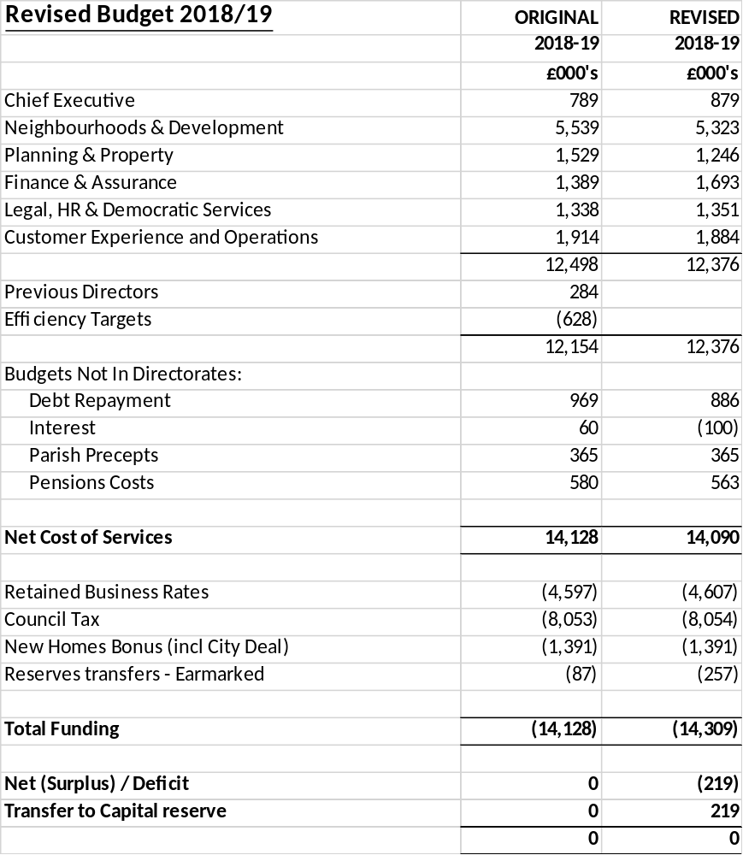
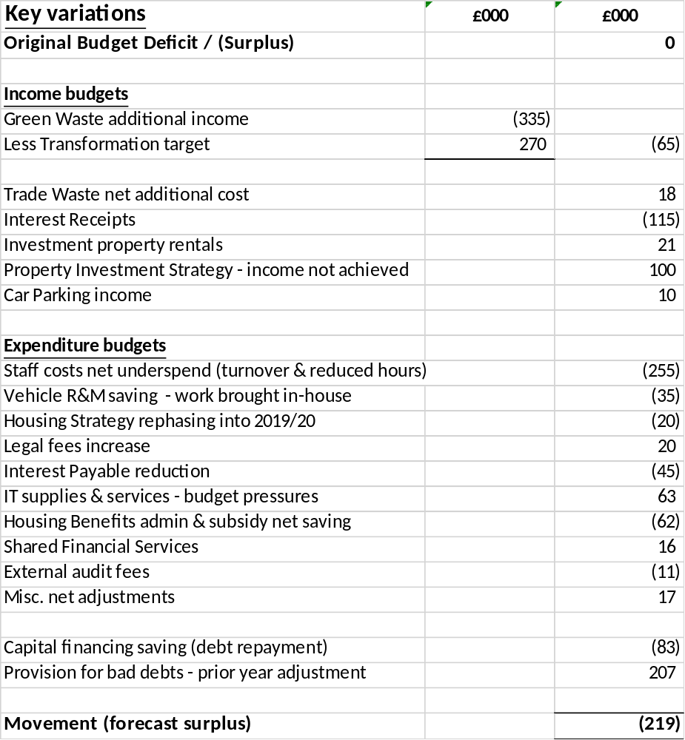

Appendix B
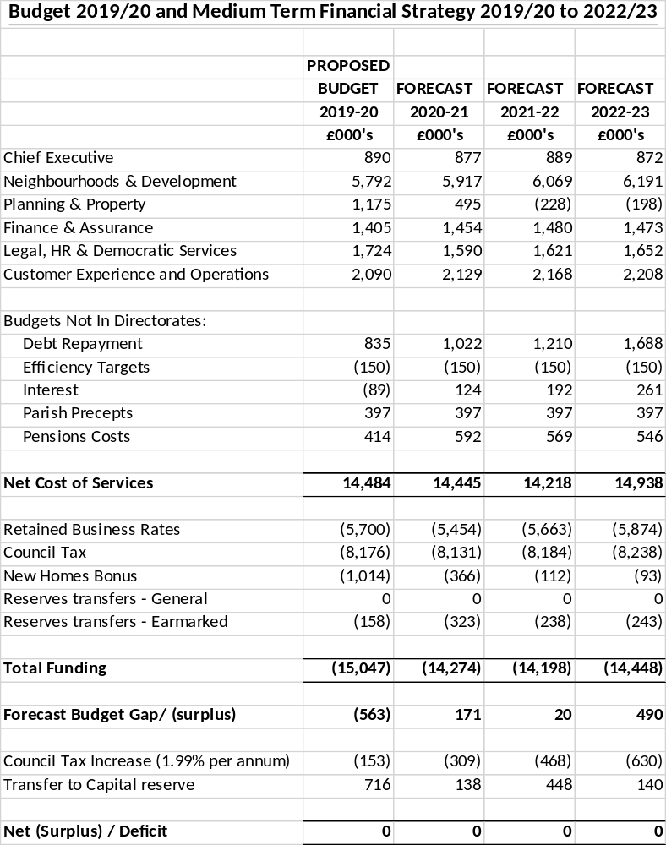

Appendix C
Budget Assumptions Summary

Budget Item | Assumption
Pay increases | 2% per annum.
Pensions Revaluation | 2% increase in employer’s rate from 2020/21.
Non-pay Inflation | Other than pay increases, inflation and growth has only been applied to expenditure budgets where contracts and demand pressures are in place.  Other expenditure budgets are generally cash limited.
Fees and charges | Retained at 2018/19 levels unless set by an external body. Separate reports will be presented if fees are to be further reviewed
Prudential Code and Capital Strategy. | Any proposed borrowing includes provision for full repayments in the forecasts. Council will seek alternative funding mechanisms to offset borrowing costs.
Reserves and Balances | The Council holds a robust level of reserves, provisions and balances. These can be utilised in the event of a unknown major budget pressure that cannot be dealt with through management actions.  The council holds reserves in the event of major funding changes that can be used for transitional periods if necessary.
Insurances | The Council through its brokers continues to monitor on an annual basis its liabilities and the necessary insurance cover required.
Council Tax Increases | 1.99% increases per annum 2019/20 to 2022/23.  The Council Tax Support Scheme continues as is until further consultation and council decisions are made.
Retained Business Rates  Baseline Funding Level | The Council has submitted a detailed NNDR1 form for 2019/20 which includes prudent estimates of business rates, appeals, bad debt provisions and changes to the rating list.  2018/19: £2.257m  2019/20: £2.309m
Business Rates Tariff | The £494k of Negative RSG has been offset for 2019/20. The MTFS assumes this is ongoing and will be reflected in any future fair funding formula.
Fair Funding Review | This detailed implications of this review are unknown and the MTFS assumes the ongoing mechanism of funding continues allowing for a prudent amount of growth.
Average Treasury Investment returns | Investments follow the treasury management strategy of the council and the returns are anticipated as follows. Funds will be invested in line with cash flow requirements of the Council  19/20: 0.9% 21/22: 1.5%  20/21: 1.25% 22/23: 1.75%
Reporting and monitoring | The Council will continue to report to members on its financial performance and will produce a budget book in March post approval.

Appendix D

CORPORATE ASSET MANAGEMENT PLAN

1. INTRODUCTION

After its staff the Council’s land and property is the next biggest resource. It is vital that this resource is managed and used effectively and efficiently. This will ensure that the Council uses its assets as a driver for change and derives maximum benefit from its assets in support of its strategic aims and priorities outlined in its Community Strategy and Corporate Plan and the wider objectives of Transformation and Health, Leisure and Wellbeing.

The continued pressure on local authority finances makes it more critical that the Council has a robust strategic approach to ensure the correct decisions are taken regarding its asset base.

The plan forms part of a suite of documents, including the Capital and Investment Strategy and Capital Programme, supporting and informing the Medium Term Financial Strategy.

The Council will continue to challenge and justify why assets are being retained, whilst looking at other alternative options for asset use and service delivery to maintain front line services within the stringent budgetary framework which local authorities continue to operate within.

2. ROLE OF ASSETS

The use and management of the Council’s assets can play a fundamental role in delivery of corporate and local priorities, delivery of housing supply as well as shape and influence the quality of life for local people and businesses.

It is critical that the assets the Council retains are fit for purpose, provide value for money and meet/support both business and community needs using a Corporate Landlord approach. Decisions to invest and improve the asset base are made on the same robust and transparent basis. Assets will only be retained where it can clearly be demonstrated they:-

- contribute to the effective delivery of business provision (i.e. the condition and performance of the asset does not impede service delivery);

- support and meet the social, economic and environmental well-being objectives of the community;

- assist in the delivery of the strategic, economic and regeneration objectives and/or;

- provide value for money (in respect of their current or future investment, capital value and/or ability to influence regeneration).

- Generate an appropriate rate of return compared to the asset value. Ensuring that appropriate lease reviews and renewals are undertaken to sweat the assets held.

Where assets do not satisfy the above criteria consideration will be given to the asset either being better utilised, freeing up accommodation elsewhere, or disposed.

The Council will adopt a planned approach to review and challenge the use, retention and rationalisation of assets, providing a transparent framework for investment and disinvestment decisions in the asset base, as well as the generation of capital receipts to support the Council’s MTFS.

3. KEY CHALLENGES

In developing a rolling 3-5 year plan the Council will need to have a flexible approach to take account and accommodate a variety of factors and challenges which will impact on the future of the asset base. In summary these include:-

National level

Local Government Settlement will continue to result in year on year challenges with the available levels of revenue and traditional forms of grant funding. All of which will place increased pressure on how the Council uses and manages its assets in support of service delivery. This will continue to place greater pressure on the Council to improve the revenue it can generate whilst at the same time make operational efficiencies through property rationalisation and improved usage of assets.

State of the property market. Whilst there has been noticeable improvements in certain sectors of the property market other areas continue to remain stagnant. As a consequence there is a greater need to bring forward property reviews. This in turn will aid generation of new income and or capital receipts as well as have a sustainable pipeline of future sites to support the Council’s MTFS.

One Public Estate. This is a Central Government initiative designed to facilitate and enable local authorities to work successfully with central government and local agencies on public property and land issues through sharing and collaboration. South Ribble will continue to identify projects that can be delivered through this initiative going forward to reduce the overall public sector property cost.

Local Government Transparency Code 2014 places a requirement on local authorities to publish and make available to local people data held and managed by the authorities. This includes data regarding the local authorities’ assets.

Corporate Level

Protection of key front line services, which will require better alignment of asset provision to service delivery to reduce operational costs and achieve additional income or efficiencies. This will necessitate greater shared use of premises, both within the Council and other organisations and targeted investment to improve retained space, where it will result in demonstrable improvements in service delivery.

Reducing level of maintenance backlog. The Council as part of its asset review will undertake a full maintenance review. Maintenance backlog can be decreased in certain areas, through investment and the sale of surplus assets, which means existing resources can be invested in the retained assets. Without investment it is expected that the situation could worsen over the next 3 - 5 years unless capital funding is identified through further asset rationalisation.

Maintaining existing income levels from the Council’s non-operational estate. The income stream derived from the investment property is good. Without a robust repairs programme the portfolio could lose value and influence (as a potential catalyst for stimulating regeneration and redevelopment schemes). Proposals will be developed to review the estate and identify the necessary investment to create a more economically viable portfolio leading to a reduction in management costs. In order to deliver this it may require upfront funding to facilitate the rationalisation of the estate and in certain circumstances investment in the actual assets to improve their condition which in turn will increase their value and marketability.

Capital Receipts. The Capital Programme remains dependent on the use of retained and new capital receipts from the sale of surplus assets. A draft property review programme will be put in place in the new financial year to look at the use of all assets. This is however a finite resource and the amount of future disposals which are not linked to a particular initiative and which therefore can be used as a “free” receipt is relative low in both numbers and value at present. New opportunities to generate capital receipts will continue to be explored and progressed.

Assets are monitored to ensure a more strategic and joined up approach to the maximisation of capital receipts, sweating of assets, revenue income opportunities, targeted acquisitions and delivery planning and resourcing.

Local Plan. As a significant landowner in the Borough the Council put forward sites in response to The Call for Sites as part of the Local Plan process. This document is a key strategic document for the Council and provides an opportunity for the Council (as landowner) to reconsider its asset base and seek to ensure its assets support the Health, Leisure and Wellbeing; Housing, economic and regeneration agenda.

Capital Investment. Details of the planned capital investment in the authority’s assets are set out in the Capital Programme. Opportunities for future investment and access to external funding in support of the Council’s assets will continue to be sourced. New capital bids will be considered on a case by case basis and prioritised when funding becomes available.

4. STRATEGIC INVESTMENT PLAN

The Council is committed to use its asset base to deliver key strategic priorities of the Community Strategy and Corporate Plan. As part of that process individual assets and where applicable land receipts could be aligned to specific pledges.

Housing – a variety of initiatives will be reviewed to support our quality housing commitments using appropriate design principles, including:

- Self Development – The Council seek options on its own land to fund and develop itself to create the right product according to housing needs whether that be affordable, elderly care or supported living.

- Stand-alone disposals of surplus land - where there is a compelling argument for the competitive marketing of the site will help both drive up values and the improve the mixed tenure of the housing product of housing.

- Strategic Housing Delivery Partnership – the Council will continue to work with borough wide housing providers to provide appropriate accommodation through land or financial investment to generate long term income returns in the form of rent and Council Tax.

Health, Leisure and Well-being – The Council will continue to develop its health, leisure and wellbeing agenda across the borough through the delivery of the following projects. Investment into quality assets and surrounding open environments will promote positive health and wellbeing.

- Green Links to connect communities across the borough encouraging physical activity and reducing car related journeys thus contributing to improved air quality.

- Investment in leisure campuses. Initial consultation on the Leyland Campus proposals are due to commence as the first phase of a borough wide initiative to improve the leisure offer across the Council.

- Parks and Open Spaces will be improved and developed as part of a borough wide initiative to be developed and brought forward for approval

- Green assets such as Worden Park will be developed and improved to make more financial sustainable whilst improving customer experience.

Business and Enterprise - the Council will either self-develop sites or continue to assist partners with major employment sites across the borough to bring forward employment and growth opportunities. Two significant examples being the sites at Cuerden and the Enterprise Zone at Samlesbury. These sites would generate significant business rate growth to assist with the Council’s Financial Sustainability.

Vehicles – The Council will ensure that its vehicle fleet is fit for purpose to the services provided. Working with the service employees on developing a strategic acquisition programme for replacements that deliver services in a more effective and efficient means.

Corporate Property and Systems– The Council continues to develop its own corporate property and IT infrastructure to generate efficiencies. Following the example of DWP being located in the Civic Centre the council will continue to identify other public sector bodies to work in partnership with. It will use its digital strategy with agile working and paperless office developments to create better utilisation of space which can be rented to third parties or public sector partners.

5. FUNDING & DELIVERY OPTIONS

If the Council is to invest in its asset base in the future it will need to consider alternative and innovative solutions to supplement more traditional funding sources as part of the resourcing strategy. All of the options listed below will continued to be looked at and where appropriate business cases will be prepared to develop these further.

- Use of Specific Capital Allocations – in relation to Housing, Sport & Leisure, disabled facilities grant etc.

- Capital Receipts – the Council will continue to take a structured approach to the release of sites to ensure it maximises land values whilst at the same time dispose of problematic sites.

- Strategic Investment opportunities – where there is a robust economic case and a prudent sustainable payback period / income stream using sustainable resources so investments can be made into Land and Property, Housing, Transformational or Business Support Projects.

- Asset transfer - to third parties & community organisations, in particular where organisations can continue to take over and provide services currently or previously delivered by the Borough or County Council.

- Securitisation against LCC Assets and/or Covenant –the gross value and Net Book value of the Council’s land and property are £42.285m and £28.147m respectively This, coupled with the strength of covenant local authorities can secure favourable lending/lease terms, meaning that investors, institutional funders, pension funds etc may be prepared to work with the Council and look at a number of financial options using the authority assets and/or its covenant as security to provide up front cash and/or longer term income stream. Options are being looked which will be subject to a full financial appraisal, notably in respect of the required rate of return and the risk profile.

- Charitable & Heritage Trusts

- Shared accommodation and/or joint developments with public partners.

- New Government funding and initiatives in partnership with other bodies.

Appendix E
SOUTH RIBBLE BOROUGH COUNCIL – CAPITAL AND INVESTMENT STRATEGY 2019/20

PURPOSE

This report sets out the proposed Capital and Investment Strategy for 2019/20 to be considered by Cabinet on 13th February 2019 and Full Council on 27th February 2019. The capital strategy supports the community strategy, the corporate plan and the key objectives of the Health & Wellbeing agenda.

BACKGROUND

The Capital and Investment Strategy is a new requirement for authorities following the publication of the revised Prudential Code for Capital Finance in Local Authorities in 2017. This statement is part of the Council’s wider financial planning framework which supports its Community Strategy and Corporate Plan. The revised Code provides clarity about what the Capital Strategy should contain and its purpose. This Capital and Investment Strategy Statement has been produced in accordance with the latest Guidance.

The Capital Strategy provides a high level overview of how capital expenditure, capital financing and treasury management activity supports the provision of services along with an overview of how associated risk is managed and the implications for future years’ budgets and financial sustainability. Consequently, the Capital Strategy maintains a strong link to the Council’s priorities, The Treasury Management Strategy, Asset Management Strategy, Digital Strategy and the Medium Term Financial Strategy

The Capital Strategy covers the following key topics:
- The capital programme including the asset management plan
- The extent of commercial activity
- The approach to risk
- Treasury management information
- Other long-term liabilities
- Knowledge and skills

CAPITAL PROGRAMME 2019/20 to 2022/23

The Council’s 2019-23 Capital Programme is set out in detail at Appendix E1. In summary the Council is proposing to spend £41.383m over the next 4 years and this is shown in the table below along with the associated financing.

Table 1 – Summary Capital Programme

Corporate Priority | Forecast2019/20  £’000 | Forecast2020/21  £’000 | Forecast 2021/22  £’000 | Forecast 2022/23  £’000 | Total  £’000
HEALTH, LEISURE & WELLBEING | 3,788 | 9,000 | 8,597 | 2,420 | 23,805
PLACE | 2,516 | 2,022 | 2,022 | 1,538 | 8,098
EXCELLENCE & FINANCIAL STABILITY | 6,604 | 1,358 | 1,205 | 313 | 9,480
TOTAL EXPENDITURE | 12,908 | 12,380 | 11,824 | 4,271 | 41,383
FINANCING:
Grants & Contributions | 1,224 | 1,382 | 4,382 | 1,032 | 8,020
S106 | 1,190 | 400 | 400 | 400 | 2,390
Capital receipts | 240 | 240 | 1,240 | 1,106 | 2,826
Revenue Reserves | 7,273 | 200 | 40 | 0 | 7,513
Unfunded/Borrowing | 2,981 | 10,158 | 5,762 | 1,733 | 20,634
TOTAL FINANCING | 12,908 | 12,380 | 11,824 | 4,271 | 41,383

All capital expenditure supports the delivery of Corporate Plan and will either contribute to specific Health, Leisure and Wellbeing, Housing, regeneration focussed objectives or will contribute to the delivery of operational service plans. Based on robust investment requirements identified in service delivery plans, other strategies or the Asset Management Plan.

Capital Appraisal Process

All new capital schemes are subject to a rigorous officer led appraisal process supported by the Councils constitution for decision making. A strategic, outline and full business case will be required for all capital projects as appropriate which:

- identifies the full construction cost on a robust model with scenario tests
- amount and source of any required funding
- is based on full lifetime costing pre, during and post construction
- sets out the planned outcomes and objectives to be delivered
- a clear timescale for delivery and responsible officers
- includes a full financial and delivery risk assessment
- incorporates appropriate due diligence in the form of financial, property and legal scrutiny (including external support when appropriate); and
- identifies the revenue impact in terms of financial affordability.

Subject to limits defined in the constitution, all new capital schemes will require Cabinet approval before they can progress. When the Cabinet approves a new scheme it will be added to the approved Capital Programme. The approved programme is monitored on a quarterly basis and performance reported at regular intervals to cabinet and committee.

Investment funds

The Council may develop through its approved investment funds and reserves new assets or acquire assets in the form of freehold and leasehold properties or make loans where the primary purpose is the pursuit of Health, Leisure and Wellbeing, Housing or regeneration objectives. As such the significant outcome may be more economic rather than a significant financial return, i.e. new jobs, housing or wider health benefit. The Council will ensure that any investment is made on a prudent basis and that any financial return could be considered over a medium or longer term to recover investment costs.

Loans

The Council may use loan funding to support projects where there is a robust self-funded business case. It may also provide short term cash flow support or longer term assistance to third parties via loans, with interest rates being determined through independent appraisal, risk analysis and having regard to State Aid legislation. Authority will be required from Full Council to approve authorised limits for any future borrowing. To manage risk the Council will seek to ensure security through the application of charges on assets or other property (intellectual property rights for instance) or appropriate director guarantees. The credit risk of the loan portfolio will be measured using the “expected credit loss” model as required under accounting standards introduced for local authorities in 2018/19.

Regeneration

Where the Council uses its own or acquire, land, property or housing assets as part of its wider regeneration priorities then it will seek to ensure that projects deliver longer term economic and financial benefits and where possible cover the capital financing costs. With regard to the acquisition of tenanted property the Council will seek to ensure that:
- assets are ideally located in the Borough for local financial and economic return, purchases outside of Borough requiring a more robust business case that protects the investment priorities within the approved Commercial Investment Strategy
- full cost analysis is undertaken on acquisition to include, surveys, purchase, SDLT and other fees.
- asset condition surveys are undertaken to understand and limit future repair and maintenance liabilities, using independent advisors as required.
- full rent analysis has been undertaken and tenants are of sound covenant.
- property appreciation is not factored into the business case
- that the remaining lease period and rent received is sufficient to cover the purchase costs, landlord liability, bad debt provisions and other associated costs. The appraisal to include loss of interest on investments if reserves are used to acquire.
- unless the asset delivers other specific priorities in the corporate plan the minimum rate of return is at least equal to the cost of financing the asset
- that the lease terms include full repairing and insuring provision and that rent review clauses are ideally upward only
- that properties include opportunities for future growth or regeneration with the associated cash benefits to the Council in the form of business rate, council tax, rent or interest growth.

Capital Financing

Wherever possible the capital programme will utilise internal funds and investment reserves to maximise external funding provided either by central government capital grant or other third party contributors (e.g. developers or other public sector agencies such as the Homes England, Sport England etc). Whilst grants and other contributions will reflect government and partner-led priorities (such as support for those with disabilities or health issues) they will nevertheless be deployed to address priority needs in the Borough.

However, the programme is also reliant on an element of internal or locally generated funding in the form of capital receipts from asset sales, direct revenue funding and prudential borrowing. In more recent years and as a result of central government changes to grant funding, capital investment plans may become increasingly reliant on capital receipts and prudential borrowing.

The Council has a significant land and property estate for operational, health, leisure and wellbeing activity and economic purposes. A review building on existing work undertaken is to be undertaken in the next six months in line with the asset management plan which will identify those assets to be retained, those developed internally and those for wider disposal. The review will reflect a balance of value against return. Where assets are identified as surplus to operational requirements they may be disposed of and the proceeds used to fund new capital expenditure or mitigate future debt. Capital receipts, however, represent a finite funding source and so some may be ring-fenced for associated development or used in such ways as to maximise the achievement of corporate priorities (including revenue efficiencies arising from Capital Receipts Flexibilities) or to finance capital schemes.

The capital programme is funded from a mix of internal and external funds. Borrowings will be used to support invest to save / earn principles to deliver transformational outcomes for the council and its overall budget. All prudential borrowing will be undertaken in full compliance with the CIPFA’s Prudential Code which sets out borrowing limits for the year and indicators to measure the affordability and sustainability of the capital programme. Unless there is a fixed future receipt the borrowing costs will include a full minimum revenue provision for the repayment of the principal elements of the debt.

Not all capital schemes will generate a return or deliver operational savings. In this case, the resulting capital financing implications are identified in reports to Cabinet along with the cost to the revenue budget. The revenue implications of capital financing decisions are monitored through the requirements of the Prudential Code. Of the £20.634m prudential borrowing included in the capital programme the majority of the investment will be on the basis of spend to save or earn. The largest element of the borrowing in the programme is against the proposed Leyland Campus project which aims to deliver a more efficient new building that is anticipated to generate greater income to the Council. Further borrowing is applied to Digital Strategy and Vehicle purchases with the aim of reducing operational costs to cover associated debt costs. These will require further cabinet and council reports

ASSET MANAGEMENT PLANNING

The Council’s property portfolio consists of a mix of operational property, health, leisure and wellbeing, investment property and property held for regeneration or housing purposes. The Council holds assets for specific reasons:

Operational – to support service provision
Health, leisure and wellbeing – to provide premises and open space for health, leisure and wellbeing of its residents.
Investment funds – to generate short and long term financial returns
Regeneration – to facilitate economic growth and strategic place-shaping
Housing – to provide investment that helps to balance the housing market for tenure, age profile and ownership models.

The Asset Management Plan, included in the Medium Term Financial Strategy, provides a framework through which these assets can be managed. It identifies that a review of the maintenance requirements of assets is required and also those assets that may be surplus can be sold to fund new capital schemes or used as a balanced contribution to wider regeneration or housing initiatives with appropriate green space provision improvements. The Asset Management Plan therefore plays a key role in shaping the Capital Programme in terms of the investment required to ensure that assets contribute to efficient service delivery.

The Council’s policy is to dispose of any surplus assets and the current Capital Programme is based on utilising £2.826 million of capital receipts of which £0.826m has already been generated. Disposing of surplus assets will also generate revenue savings associated with the cost of maintaining empty or underused properties. Decisions to dispose of assets at best consideration (subject to delegated limits to officers) are taken by the Cabinet. The capital receipts forecast underpinning the capital programme is as flows:

COMMERCIAL INVESTMENT STRATEGY

A Property Investment Fund property acquisition has been agreed with the aim of generating long term rental income streams. This expenditure has been carried over into the proposed capital programme for 2019/20, financed from internal reserves.

These funds will be utilised across a wider remit to deliver long term financial benefits so could see projects being brought forward to support employment, housing and commercial return. The income generated from the acquisitions will support the operating expenditure, reinstatement of the reserves and management costs of the properties with any surplus available to help fund Council services. In consideration of this investment the Council will identify the wider impacts through data management of its decisions such as reducing unemployment and the impacts of benefits and Council Tax

With any capital investment governance and due diligence are of paramount importance. In this respect a review of governance will confirm or amend the approval processes. The Councils agreed Commercial Property Investment Strategy has due regard to the Council’s risk appetite, the criteria for project appraisal including financial return, risk assessment and location of properties. The Strategy recognises the risk that investment performance is not guaranteed and aims to limit this risk by following set criteria for purchase and due diligence of the properties and prospective tenants. Income streams can be either short term capital receipts or longer term revenue benefits. The Commercial property Investment strategy has been previously approved and subject to future decisions on specific investments.

There are a number of key risks associated with property acquisitions. Some of these risks have already been referred to in the section on Investments and Loans, however, there are additional risks associated with a purely commercial property acquisition strategy; these include:
- the extent to which commercial income supports the revenue budget. Over-reliance on commercial income will have a significant impact if those income streams are reduced.
- Proportionality or the size of the commercial investment portfolio in relation to the Council’s other asset classes on the Balance Sheet.
- capital depreciation arising from a downturn in economic conditions and which debt costs will be based on the higher purchase cost of assets.
- economic decline generally which may affect both income streams and capital values.
- decision-making arising either from inadequate governance arrangements and / or poor business modelling.

GOVERNANCE FRAMEWORK

The Council’s Capital Programme involves the expenditure and financing of £41.383m of capital schemes over the period 2019/20 to 2022/23. It is important therefore given the risks surrounding capital projects that appropriate governance arrangements are in place. For the Council these governance arrangements encompass:

- The Capital Strategy Statement and the Medium Term Capital Programme are approved annually at Cabinet and Full Council.
- Cabinet will be in receipt of reports to approve schemes and their funding
- The Governance and Scrutiny Committees are responsible for scrutinising the Capital Programme and the associated Cabinet Reports.
- The Leadership Team has overall responsibility for the management and monitoring of the Capital Programme.
- Officers will engage with all members in the consultation process of approving schemes and their expenditure.
- The Constitution (including Financial Regulations, the Scheme of Delegation and Contract Standing Orders) which sets out the powers of the Executive and Senior Officers with regard to capital expenditure
- Each quarter the Scrutiny Committee will receive a capital monitoring report which identifies any variation to the approved programme arising either from the re-phasing of schemes, changes in resource availability and requirements and new capital schemes
- All capital expenditure is guided by the Council’s financial accounting framework which ensures that only expenditure that properly falls as capital expenditure in accordance with accounting convention is capitalised
- The Capital Programme is subject to both Internal and External Audit scrutiny

TREASURY MANAGEMENT

The Treasury Management Policy Statement attached to this Medium Term Financial Strategy is produced annually and approved by the Council as part of the budget setting process.

The Treasury Management Policy Statement and the Capital Strategy are closely linked. The Capital Programme identifies the funding needs of the Council over a medium term period. The Treasury Management Policy Staement considers these longer term cash flow needs and sets out how the Council will manage these cash requirements. This may involve arranging investments and loans taking decisions on whether they should be short or long term having regard to prevailing and forecast interest rates. The Treasury Management Policy Staement will also consider the Council’s cash surpluses and how these should be managed. At times it may be beneficial to defer borrowing and use these cash surpluses to avoid lending and thereby save paying interest costs. The Council has successfully pursued a policy of internal borrowing using its cash surpluses whilst simultaneously keeping a close watch over interest rates for signs that they may increase. In terms of increasing interest rates the Council will continue to monitor markets in relation to investing surplus cash against the requirements of the capital programme expenditure.

Borrowing Limits

The Capital Programme assumes a level of borrowing that will need to be taken out to fund the overall programme. The Council will continue to seek alternative funding sources to mitigate borrowing. In the event of having to borrow the Council will seek to maximise spend to save / earn opportunities such that debt repayment is covered from service efficiency or new income streams.

In the event the council enters into external borrowing requirements the Prudential Code requires authorities to set two limits at its Full Council meeting for external debt each year:
- Authorised limit - this represents the maximum limit for external debt, including PFI liabilities, taking account of fluctuations in day to day cash requirements
- Operational Boundary - this limit is based on the authority’s estimate of most likely amount of borrowing required. The Council is currently not borrowing as a result of pursuing an internal borrowing policy for the last few years to reduce financing costs.

Minimum Revenue Provision

The Council has a statutory requirement to set aside a prudent amount each year as a provision for the repayment of debt, known as the Minimum Revenue Provision (MRP). The amount to be set aside as MRP is governed by statutory guidance, however in practice it is left for each authority to determine what a prudent amount should be. The Council calculates MRP broadly in relation to the expected life of the assets being funded from borrowing either internally or externally; any detailed MRP Strategy to be approved by the Council will set out the full policy.

Financial (Treasury Management) Investments

When the Council has surplus cash this may be invested to earn a return. The Treasury Management Policy Statement sets out how the Council manages risk associated with its investments. Investments are anticipated to be £35 million at the end of 2018/19. Beyond this date it is difficult to predict what investments may be held as that will depend on what happens to the interest rates and how the Council intends to spend its reserves and other unallocated funds.

The Council may decide to invest in other models to deliver its strategic outcomes. Additional reports will be presented at the time decisions will need to be made.
Governance

Treasury Management activity is governed by the requirements of the CIPFA Treasury Management Code. The Council complies with all aspects of the Code; an annual Strategy Statement is approved by Full Council as part of the budget setting process, a mid-year update report is provided to Governance Committee and an outturn report produced in June. The Governance Committee is responsible for the oversight and governance of all Treasury Management activity.

APPROACH TO MANAGING RISK

Risk is inherent with any investment or commercial activity and whilst it cannot be entirely eliminated the Council can adopt a strategic approach to its management by establishing a clear policy setting out what risk level it is prepared to tolerate. This will be the Council’s risk appetite. The Council’s risk appetite is to balance risk and return in pursuit of its corporate objectives. In this way the Council has an understanding of the adverse aspects of risk and can take steps to mitigate it when making decisions.

It should be noted, however, that the risk referred to in the Capital Strategy is only one part of the Council’s overall risk management arrangements and needs to be seen in the context of the overall risk management framework, the governance arrangements and the monitoring and reporting procedures. With regard to general risks the Council produces a Corporate Risk Register and to manage risk capacity has reserves. Other key business risk alignment processes include: the MTFS, internal audit, budget setting and monitoring framework, treasury management arrangements, performance management framework, and external audit.

The Council is exposed to a number of investment and commercial risks:

- Financial risk relating to the investment of cash, market volatility, currency markets. Transparent decisions will be made utilising appropriate due diligence. The council will apply the principles of Security, Liquidity and Yield with all investments. The Council has no appetite for volatile, currency or high risk markets.
- Economic risk relating to whether the local / national economy is growing or contracting. The Council will have a balanced approach for this area allocating funds to employment, housing and property investment. Some projects will yield good financial returns with others less so whilst creating economic growth. There is little appetite for projects that have identified interest rate and inflationary pressures.
- Counterparty risk relating to investments, loans to third parties and business transactions based on robust due diligence and Treasury policy management.
- Operational the Council have a low appetite for risk arising from transactions, service delivery, IT security, etc
- Strategic risk relating to the decisions taken by the Council in pursuit of its corporate objectives identified in the Corporate Plan, i.e. the purchase of major new assets including vehicles for service delivery.
- Reputational the Council has no appetite for risk relating to the adverse impact of the Council’s dealings
- Environmental and social the Council has no appetite to risks arising from the adverse impacts of its investment.
- Governance risk relating to the transparency and accountability of decisions and decision-makers.

KNOWLEDGE AND SKILLS

Both the Capital Programme and the Treasury Management Strategy are managed by teams of professionally qualified accountants with considerable experience of local government finance. Officers maintain and develop their skills and knowledge through a programme of Continuous Professional Development and by attending various courses and conferences held by CIPFA and other sector experts on an on-going basis.

The Deputy Chief Executive in his capacity as Section 151 Officer is also a professionally qualified accountant. The Section 151 Officer has the overall responsibility for ensuring the proper management of the Council’s finances including the Capital Programme, Asset portfolio and Treasury Management activity.

The property elements of the programme are also led by a group of professionally qualified officers including RICS supported by external advisors to ensure valuation and rental values are appropriately assessed.

The Governance Committee is the body which oversees all aspects of the Capital Strategy. Internal and external training is to be made available to Members of the Committee to ensure that they have the skills and understanding required to make capital and treasury decisions.

When required internal skills and knowledge will be supplemented by external advisors. For example, the Council uses LINK Asset Services to provide advice on Treasury Management issues.

Appendix E1
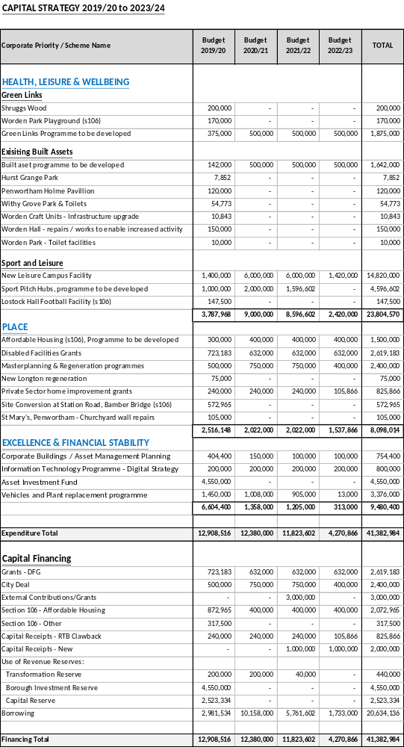

Appendix F
Capital Programme 2019/20 to 2022/23

The current capital programme for 2018/19 as identified in the second quarter report is highlighted in the table below. An element of project review has been undertaken and certain projects have been carried forward into the 2019/20 programme. The quarter three report will update members in due course.

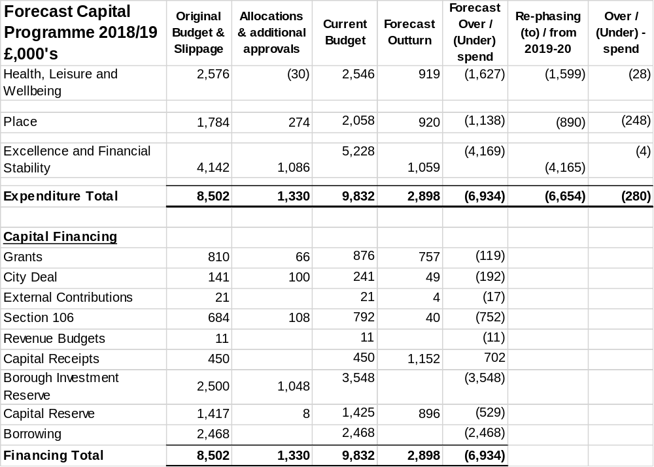

Programme Bids

Table 1 below gives an indicative Capital Programme for 2019/20 onwards based on current information on schemes and funding. The capital programme is subject to continuous change as new resources and projects are identified especially contributions through S106 and other external funds, and will be updated throughout the year. In addition, other major regeneration and Health and Wellbeing projects will be brought forward to Cabinet and Council for approval.

Table 1 – Indicative 2019/20 to 2022/23 Capital Programme

Corporate Priority | Forecast2019/20  £’000 | Forecast2020/21  £’000 | Forecast 2021/22  £’000 | Forecast 2022/23  £’000 | Total  £’000
HEALTH, LEISURE & WELLBEING | 3,788 | 9,000 | 8,597 | 2,420 | 23,805
PLACE | 2,516 | 2,022 | 2,022 | 1,538 | 8,098
EXCELLENCE & FINANCIAL STABILITY | 6,604 | 1,358 | 1,205 | 313 | 9,480
TOTAL EXPENDITURE | 12,908 | 12,380 | 11,824 | 4,271 | 41,383
FINANCING:
Grants & Contributions | 1,224 | 1,382 | 4,382 | 1,032 | 8,020
S106 | 1,190 | 400 | 400 | 400 | 2,390
Capital receipts | 240 | 240 | 1,240 | 1,106 | 2,826
Revenue Reserves | 7,273 | 200 | 40 | 0 | 7,513
Unfunded/Borrowing | 2,981 | 10,158 | 5,762 | 1,733 | 20,634
TOTAL FINANCING | 12,908 | 12,380 | 11,824 | 4,271 | 41,383

All future capital schemes will be subject to a robust appraisal and approval process outlined in the Capital and Investment Strategy that will ensure the programmes of works meets key priorities of the Community Strategy and Corporate plan, are financially affordable, have a robust procurement strategy and delivery timetable. These projects will be subject to Cabinet and/or Council approvals and scrutiny at appropriate Committees.

Further projects and programmes may need to be approved prior to the new financial year. These will be incorporated into the regular monitoring reports after gateway approval.

Funding the Programme

The table above also highlights the means in which this programme is to be funded

The programme is funded on the assumption Government department grants are allocated to the relevant programmes. It also reflects investments to deliver key priorities around the Health Leisure & Wellbeing agenda.

The Council will continue to seek and secure further additional private and grant resources where possible to both reduce ongoing borrowing and revenue implications and to enhance the overall programme. The constitution will be reviewed for approval processes on the capital programme to improve delivery and outcomes.

Capital receipts are based on actuals received and an indicative target for a disposal programme of vacant land and property as advised by the Asset Management Plan. Those receipts generated will contribute towards the funding of the capital programme, fund service transformational change or to offset unsupported borrowing and therefore reduce the ongoing revenue implications.

The reserve contributions are those identified for strategic property investments and other transformational improvements.
Significant future grant allocations are anticipated through Sport England for health and wellbeing projects and the ongoing allocation of Disabled Facilities Grants.

The current programme shows a level of unsupported borrowing, which is being used in the main to fund a proposed Leyland Campus including infrastructure investment and improved service delivery. Details of the major schemes are included in the analysis below. The increased cost of borrowing is reflected in the revenue estimates and takes into account the returns generated in the form of efficiencies, rental income, and or loan returns. The benefits generated are anticipated to exceed the debt costs and contribute to the Council’s overall budget position. Further income and benefits outside of the appraisal process include growth in business rate, council tax, employment opportunities reducing reliance on benefits and economic growth.

Future projects funded from borrowing will need to evidence full pay back or generate surpluses over the lifetime and focus on those schemes that deliver the Corporate Plan priorities. Each project will be subject to appraisal and a gateway approval process before Cabinet and/or Council approval. The capital programme will evolve in the year and regular updates will be provided.

Overview of Strategic Programme areas;

Health, Leisure and Wellbeing
- Green Link, park and open space improvements funded by specific existing section 106 agreements. Spend profile will reflect those receipts already in the reserves and new amounts only progressing on the basis of new housing developments commencing. A full review of S106 will take in the first six months of the financial year with a further paper presented to Cabinet.

- The programme also includes a number of improvements to existing built assets and public facilities to tackle maintenance issues and improve the quality of service provision. Particular emphasis on Worden Hall and park improvements designed to increase levels of activity and utilisation.

- Proposed Leyland Campus and other sports facilities outlined in report to Cabinet on the 25th January 2018. Subject to public consultation and planning the capital forecasts make allowance for the construction of new Leisure Campus including an estimate of third party grant contributions that could be received to fund the project. Along with sports pitch improvements the programme includes the Lostock Hall Football facility project funded by S106

Place
- Building on the S106 review the Council will bring forward proposals to utilise its own resources for affordable housing and support for private sector regenerations schemes. The aim of the programme to provide housing that satisfies a balances approach to tenure, age related provision and ownership.

- The Council will continue to work with other providers and individuals to provide a robust disabled facilities grant scheme.

- The programme includes the conversion of the vacant former council offices in Station Road, Bamber Bridge into affordable housing units with office space on the ground floor.

Excellence and Financial Sustainability
- Corporate buildings investment to increase utilisation of property, create third party income and deliver operational efficiencies.

- A report will be presented to cabinet regarding the medium term digital strategy. This will review all existing systems seeking to drive efficiency through Information Technology, paperless office and utilisation of data. The programme will also review IT hardware to increase agile working for front line services enabling officers to work off site and or directly with customers.

- The Council has already approved an investment fund for the acquisition of commercial property for income generation and or economic growth. New approvals will be taken forward within the decision making process when opportunities arise to acquire property after a robust due diligence exercise.

- To ensure robust and efficient front line service delivery of environmental services the Council has a planned vehicle replacement policy. During the procurement process the council will consult with the front line operators to ensure that the most efficient and environmental friendly vehicles are acquired using a robust appraisal process. The council will consider all fuel options including diesel, compressed natural gas, petrol or electric in its decisions.

APPENDIX F1
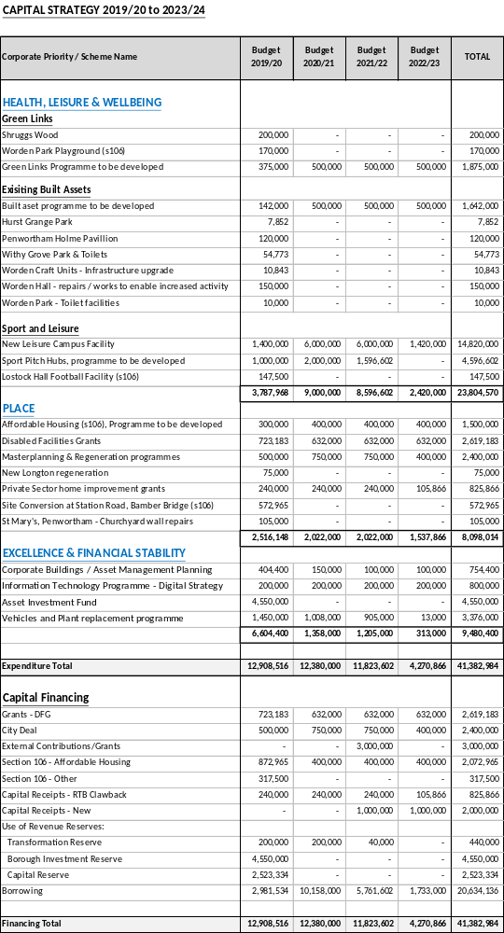

Appendix G
Treasury Management Policy Statement 2019/20

- PURPOSE OF THE REPORT

To present the Prudential and Treasury Indicators and Treasury Management and Investment Strategies for 2019/20 to 2022/23, and the Minimum Revenue Policy Statement for 2019/20.

- BACKGROUND TO THE REPORT

  - For each financial year the City Council sets a balanced budget so that cash income raised during the year is sufficient to meet all of its cash expenditure commitments. One of the key functions of the City Council’s treasury management activity is to ensure that these cash flows are effectively managed, so that cash is available when it is needed. Surplus cash is invested having regard to risk, liquidity and yield.

  - A further key function of the treasury management activity is to ensure that the City Council has sufficient funds to pay for its capital and other investment plans. These capital plans, which are set out in the Capital Programme, identify the borrowing needs of the City Council over a longer time horizon than the current year. In managing its longer term cash flow requirements for capital expenditure the City Council will take out loans or alternatively use its cash flow surpluses in lieu of external borrowing. This latter practice is referred to as “internal borrowing”. In managing its loans, it may at times be advantageous for the City Council to repay or restructure its borrowings to optimise interest payments or achieve a balanced debt portfolio.

  - Having regard to these activities, the Chartered Institute of Public Finance and Accountancy (CIPFA) defines treasury management as:

“The management of the Council’s investments and cash flows, its banking, money market and capital market transactions; the effective control of the risks associated with those activities; and the pursuit of optimum performance consistent with those risks.”

  - As treasury management decisions involve borrowing and investing substantial sums of money, the City Council is exposed to potentially large financial risks, including the loss of invested funds and the revenue effect of changing interest rates. The identification, control and monitoring of risk are therefore integral elements of treasury management activity.

  - The Treasury Management Policy Statement for 2018/19 is based upon the Chief Finance Officer and Treasury Officers’ views on interest rates supplemented by leading market forecasts. The policy statement covers:

- The policy for managing capital borrowing and debt rescheduling
- The annual investment strategy for treasury management investments
- Reporting arrangements
- Training arrangements
- Performance indicators
- Minimum Revenue Provision (MRP) Policy
- Use of treasury management advisors

  - Council of 28 February 2018 approved the Treasury Management Strategy for 2018/19, including Prudential and Treasury Indicators, the Treasury Management and Investment Strategies, and the annual Minimum Revenue Provision (MRP) Policy Statement for 2018/19. Treasury Management activities during the year have been overseen by the Governance Committee.

  - Council of 5 December 2018 approved amendments to the list of Investment Counterparties to include Low Volatility Net Asset Value (LVNAV) Money Market Funds (MMFs), and to increase the limit per UK local authority, bank or building society from £5m to £6m. No changes to Investment Counterparties and limits are proposed in this report.

  - This report updates Prudential and Treasury Indicators for financial years 2018/19 to 2022/23. It presents updated Treasury Management and Investment Strategies, including a revised list of Investment Counterparties, and proposes the Minimum Revenue Policy Statement for 2019/20.

- TREASURY MANAGEMENT STRATEGY 2019/20

  - The strategy for 2019/20 covers two main areas:

Capital issues
- the capital plans and the Prudential Indicators;
- the Minimum Revenue Provision (MRP) policy.

Treasury management issues
- the current treasury position;
- Treasury Indicators which limit the treasury risk and activities of the Council;
- prospects for interest rates;
- the borrowing strategy;
- policy on borrowing in advance of need;
- debt rescheduling;
- the investment strategy;
- creditworthiness policy; and
- the policy on use of external service providers.

  - These elements cover the requirements of the Local Government Act 2003, the CIPFA Prudential Code, MHCLG MRP Guidance, the CIPFA Treasury Management Code, and MHCLG Investment Guidance.

  - On 2 February 2018 The Ministry of Housing, Communities & Local Government issued its Statutory Guidance on Local Government Investments (3rd edition) and Statutory Guidance on Minimum Revenue Provision.

- TRAINING

  - The CIPFA Code requires the Responsible Officer to ensure that members with responsibility for treasury management receive adequate training in treasury management. This especially applies to members responsible for scrutiny. Training will be provided on the implications of the revised CIPFA Prudential and Treasury Management Codes, and the revised MHCLG Investment Guidance and MRP Guidance.

  - The training needs of treasury management officers are reviewed periodically. Both CIPFA and Link Asset Services provide workshops and seminars.

- TREASURY MANAGEMENT CONSULTANTS

  - The Council uses Link Asset Services, Treasury solutions as its external treasury management advisors. The advisors provide access to specialist skills and resources including

- Technical support on treasury matters and capital finance issues.
- Economic and interest rate analysis.
- Debt services, which includes advice on the timing of borrowing.
- Debt rescheduling advice surrounding the existing portfolio.
- Generic investment advice on interest rates, timing and investment instruments.
- Credit ratings/market information service comprising the three main credit rating agencies.

  - The Council recognises that responsibility for treasury management decisions remains with the organisation at all times and will ensure that undue reliance is not placed upon our external service providers.

  - The Council will ensure that the terms of their appointment and the methods by which their value will be assessed are properly agreed and documented, and subjected to regular review.

- CAPITAL PRUDENTIAL INDICATORS 2019/20 – 2022/23 and mrp statement

  - The Council’s capital expenditure plans are the key driver of treasury management activity. The output of the capital expenditure plans is reflected in the prudential indicators, which are designed to assist members’ overview and confirm capital expenditure plans.

  - Capital expenditure

This prudential indicator is a summary of the Council’s capital expenditure plans, both those agreed previously, and those forming part of this budget cycle.

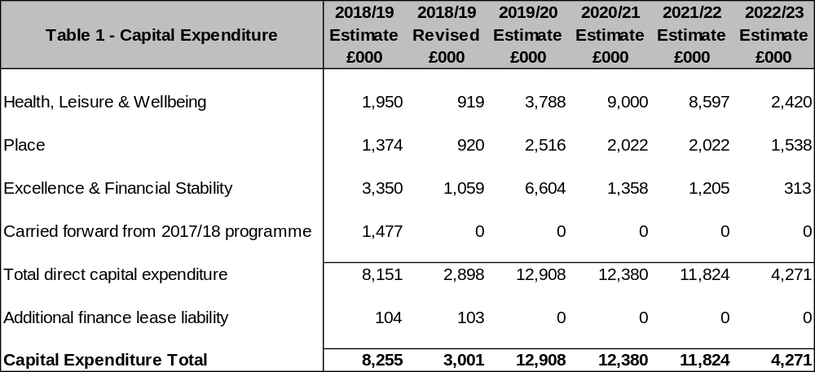

The table below summarises the above capital expenditure plans identified in the Capital & Investment Strategy and the Capital Programme and how these plans are being financed by capital or revenue resources. Any shortfall of resources results in a borrowing requirement.

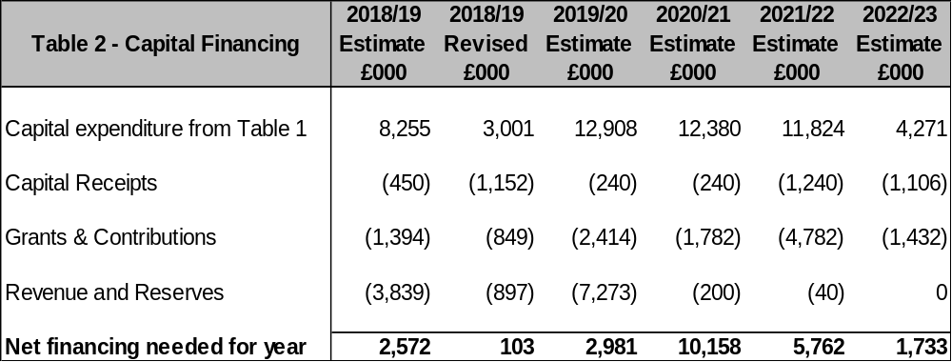The Council’s borrowing need (the Capital Financing Requirement)

The second prudential indicator is the Council’s Capital Financing Requirement (CFR). The CFR is simply the total historic outstanding capital expenditure which has not yet been paid for from either revenue or capital resources. It is essentially a measure of the Council’s indebtedness and so its underlying borrowing need. Any capital expenditure above, which has not immediately been paid for, will increase the CFR.

The CFR does not increase indefinitely, as the Minimum Revenue Provision (MRP) is a statutory annual revenue charge which broadly reduces the indebtedness in line with each assets life, and so charges the economic consumption of capital assets as they are used.

The CFR includes any other long-term liabilities (finance leases). Whilst these increase the CFR, and therefore the Council’s borrowing requirement, these types of scheme include a borrowing facility by the lease provider and so the Council is not required to separately borrow for these schemes:

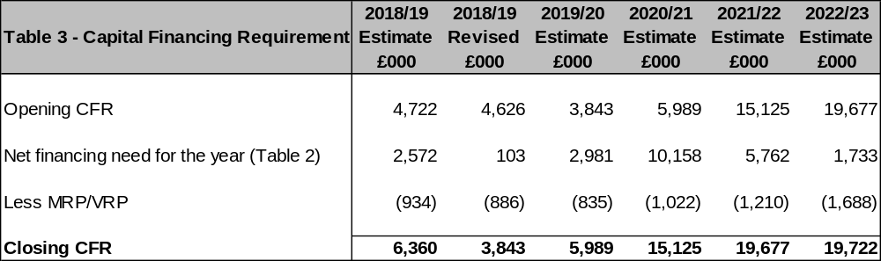

  - Minimum Revenue Provision (MRP)

The Council has a statutory requirement to set aside each year part of their revenues as a provision for the repayment of debt, called the Minimum Revenue Provision (MRP). The provision is in respect of capital expenditure incurred in previous years and which has been financed by borrowing.

The statutory requirement per the Local Authorities (Capital Finance and Accounting) (England) (Amendment) Regulations 2008 [SI 2008/414] is for each local authority to determine an amount of MRP which it considers to be “prudent”.

As “prudence” is not defined in the regulations, the MHCLG had issued accompanying statutory guidance (2012) which explained that the broad aim of a “prudent provision” is to ensure that the debt is repaid over a period that is either, reasonably commensurate with the period over which the capital expenditure provides benefit, or, in the case of borrowing supported by formula grant, reasonably commensurate with the period implicit in the determination of that grant. Each authority must determine what they consider is a prudent amount while having regard to the guidance.

The guidance also recommends that each local authority prepare an annual statement of its strategic policy on making MRP, to be approved by the full Council. A variety of options are provided to councils in the regulations, so long as there is a prudent provision.

For capital expenditure incurred before 1 April 2008 Option 1 is applied

This provides for local authorities to continue to calculate MRP in line with the minimum existing statutory charge of 4% of outstanding debt related to supported borrowing only, less an adjustment that ensures consistency with previous capital regulatory regimes no longer in force.

From 1 April 2008 for all unsupported borrowing (finance leases) the MRP policy will be Option 3 – Asset Life Method

This method is appropriate for calculating MRP in relation to debt incurred as unsupported borrowing (also known as prudential borrowing), and must be used for revenue expenditure capitalised by direction or regulation. Under this option there are two methods available:

- (Equal instalment method. This generates a series of equal annual amounts over the life of each asset that is financed by borrowing, with the life determined upon acquisition. This means that the charge to revenue closely matches the period of economic benefit of the asset.
- Annuity method. This method links the MRP to the flow of benefits from an asset where the benefit is expected to increase in later years.

Under this option, authorities should consider the type of assets that they finance through prudential borrowing, as the type of asset and its useful life may have a significant impact on the level of MRP charged. Where expenditure is capitalised by direction or regulation, the guidance specifies certain maximum lives to be used in the calculation.

Finance Leases and PFI
The guidance indicates that for finance leases and on-balance sheet PFI contracts, the MRP requirement could be met by making a charge equal to the element of the finance lease rental that goes to write down the balance sheet liability under proper accounting practices.

  - Affordability prudential indicators

The previous sections cover the overall capital and control of borrowing prudential indicators, but within this framework prudential indicators are required to assess the affordability of the capital investment plans. These provide an indication of the impact of the capital investment plans on the Council’s overall finances. The Council is asked to approve the following indicator:

Ratio of financing costs to net revenue stream

This indicator identifies the trend in the cost of capital (borrowing and other long term obligation costs net of investment income) against the net revenue stream.

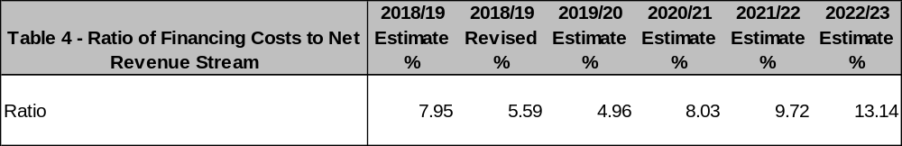

The estimates of financing costs include current capital commitments and the proposals in the Budget and Capital and Investment Strategy reports. The increasing ratio for the remainder of the budget period reflects the additional level of borrowing required to finance the Council’s planned Capital Programme. However, the intention for schemes funded through borrowing is that they will deliver a financial return and therefore ensure the sustainability of the City Council’s debt financing costs.

  - Core funds and expected investment balances

The application of resources (capital receipts, reserves etc.) to either finance capital expenditure or other budget decisions to support the revenue budget will have an ongoing impact on investments unless resources are supplemented each year from new sources (asset sales etc.).

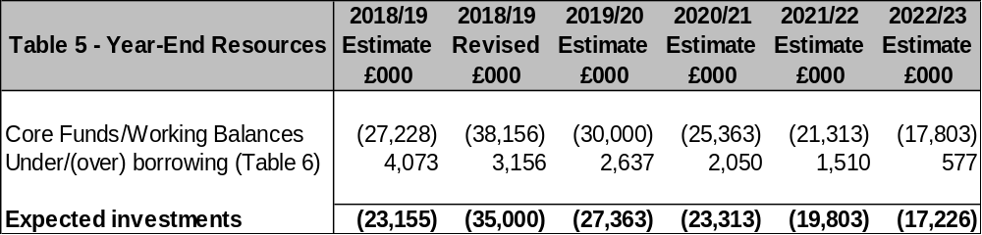

- borrowing

  - The capital expenditure plans set out in paragraph 8.2 above provide details of the service activity of the Council. The treasury management function ensures that the Council’s cash is organised in accordance with the relevant professional codes, so that sufficient cash is available to meet this service activity and the Council’s capital strategy. This will involve both the organisation of the cash flow and, where capital plans require, the organisation of appropriate borrowing facilities. The strategy covers the relevant Treasury / Prudential Indicators, the current and projected debt positions and the annual Investment Strategy.

  - Current portfolio position

  - The Council’s treasury portfolio position at 31 March 2018, with forward projections, is summarised below. The table shows the actual external debt (the treasury management operations), against the underlying capital borrowing need (the Capital Financing Requirement - CFR), highlighting any over or under borrowing.

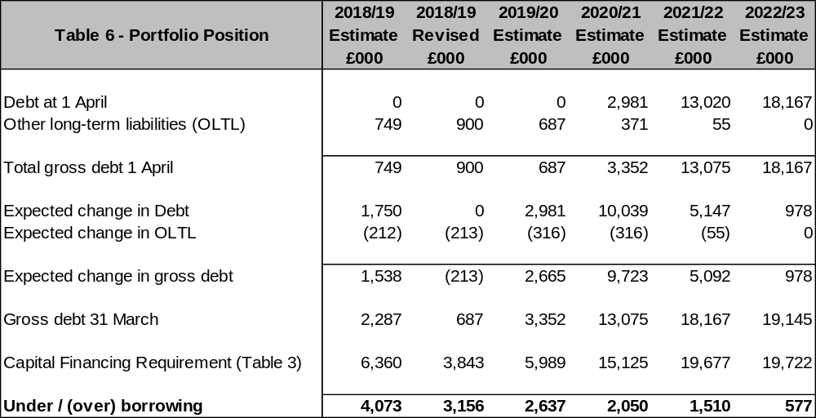

  - Within the prudential indicators there are a number of key indicators to ensure that the Council operates its activities within well-defined limits. One of these is that the Council needs to ensure that its gross debt does not, except in the short term, exceed the total of the CFR in the preceding year plus the estimates of any additional CFR for 2019/20 and the following two financial years. This allows some flexibility for limited early borrowing for future years, but ensures that borrowing is not undertaken for revenue or speculative purposes.

  - The Council complied with this prudential indicator in the current year and does not envisage difficulties for the future. This view takes into account current commitments, existing plans, and the proposals in this budget report.

  - Treasury Indicators: limits to borrowing activity

The Operational Boundary. This is the limit beyond which external debt is not normally expected to exceed. In most cases, this would be a similar figure to the CFR, but may be lower or higher depending on the levels of actual debt and the ability to fund under-borrowing by other cash resources.

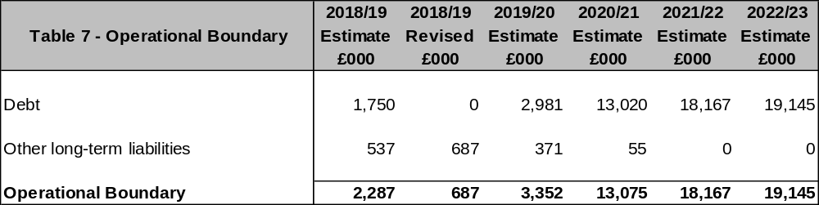

The Authorised Limit for external debt. A further key prudential indicator represents a control on the maximum level of borrowing. This represents a limit beyond which external debt is prohibited, and this limit needs to be set or revised by the full Council. It reflects the level of external debt which, while not desired, could be afforded in the short term, but is not sustainable in the longer term.

- This is the statutory limit determined under section 3 (1) of the Local Government Act 2003. The Government retains an option to control either the total of all councils’ plans, or those of a specific council, although this power has not yet been exercised.

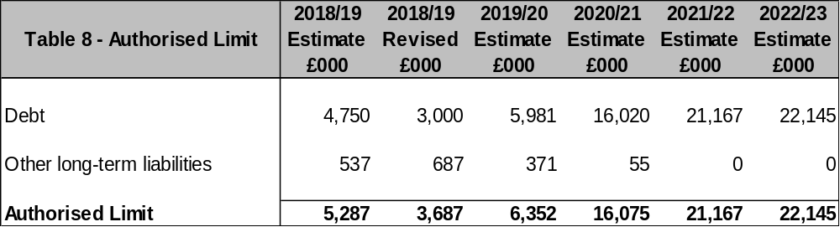

  - Maturity structure of borrowing

These gross limits are set to reduce the Council’s exposure to large fixed rate sums falling due for refinancing, and are required for upper and lower limits.

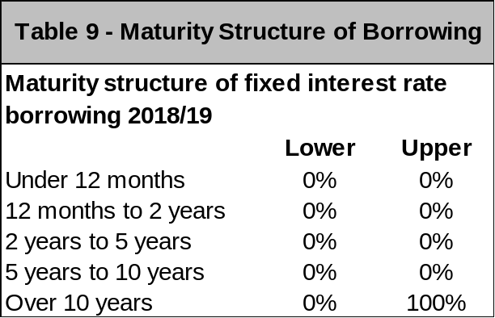

It is not anticipated that any borrowing will be taken at variable interest rates.

  - Control of interest rate exposure

Please see paragraphs 9.9, 10.4 and Appendix B and C.

Appendix C compares the forecast of a year ago with that prepared for the mid-year review, and the current forecast.

  - Borrowing strategy

The Council is currently maintaining an under-borrowed position. This means that the capital borrowing need (the Capital Financing Requirement), has not been fully funded with loan debt as cash supporting the Council’s reserves, balances and cash flow has been used as a temporary measure. This strategy is prudent as investment returns are low and counterparty risk is still an issue that needs to be considered.

Against this background and the risks within the economic forecast, caution will be adopted with the 2019/20 treasury operations. The Deputy Chief Executive – Resources & Transformation (S151 Officer) will monitor interest rates in financial markets and adopt a pragmatic approach to changing circumstances:

- if it was felt that there was a significant risk of a sharp FALL in long and short term rates (e.g. due to a marked increase of risks around relapse into recession or of risks of deflation), then long term borrowings will be postponed, and potential rescheduling from fixed rate funding into short term borrowing will be considered.

- if it was felt that there was a significant risk of a much sharper RISE in long and short term rates than that currently forecast, perhaps arising from an acceleration in the start date and in the rate of increase in central rates in the USA and UK, an increase in world economic activity or a sudden increase in inflation risks, then the portfolio position will be re-appraised. Most likely, fixed rate funding will be drawn whilst interest rates are lower than they are projected to be in the next few years.

Any decisions will be reported at the next available opportunity.

  - Policy on borrowing in advance of need

The Council will not borrow more than or in advance of its needs purely in order to profit from the investment of the extra sums borrowed. Any decision to borrow in advance will be within forward approved Capital Financing Requirement estimates, and will be considered carefully to ensure that value for money can be demonstrated and that the Council can ensure the security of such funds.

Risks associated with any borrowing in advance activity will be subject to prior appraisal and subsequent reporting through the mid-year or annual reporting mechanism.

- annual investment strategy

  - Investment Policy

The Council’s investment policy has regard to the CLG’s Guidance on Local Government Investments (“the Guidance”) and the CIPFA Treasury Management in Public Services Code of Practice and Cross Sectoral Guidance Notes 2017 (“the CIPFA TM Code”). The Council’s investment priorities will be Security first, portfolio Liquidity second, and only then return (Yield).

In accordance with the above guidance from the CLG and CIPFA, and in order to minimise the risk to investments, the Council applies minimum acceptable credit criteria in order to generate a list of highly creditworthy counterparties which also enables diversification and thus avoidance of concentration risk. The key ratings used to monitor counterparties are the Short Term and Long Term ratings.

Ratings will not be the sole determinant of the quality of an institution; it is important to continually assess and monitor the financial sector on both a micro and macro basis and in relation to the economic and political environments in which institutions operate. The assessment will also take account of information that reflects the opinion of the markets. To achieve this consideration the Council will engage with its advisors to maintain a monitor on market pricing such as “credit default swaps” and overlay that information on top of the credit ratings.

Other information sources used will include the financial press, share price and other such information pertaining to the banking sector in order to establish the most robust scrutiny process on the suitability of potential investment counterparties.

Treasury Management Practice 1 (TMP1) deals with credit and counterparty risk management. In applying this practice, the following limits are relevant:

SPECIFIED INVESTMENTS: All such investments will be sterling denominated, with maturities up to maximum of 1 year, meeting the minimum ‘high’ quality criteria where applicable.

NON-SPECIFIED INVESTMENTS: These are any investments which do not meet the specified investment criteria. A maximum of £6m will be held in aggregate in non-specified investments, specifically term deposits with UK local authorities.

  - Creditworthiness policy

The Council applies the creditworthiness service provided by Link Asset Services. This service employs a sophisticated modelling approach utilising credit ratings from the three main credit rating agencies - Fitch, Moody’s and Standard & Poor’s. The credit ratings of counterparties are supplemented with the following overlays:

- credit watches and credit outlooks from credit rating agencies;
- CDS spreads to give early warning of likely changes in credit ratings;
- sovereign ratings to select counterparties from only the most creditworthy countries.

This modelling approach combines credit ratings, credit Watches and credit Outlooks in a weighted scoring system which is then combined with an overlay of CDS spreads for which the end product is a series of colour coded bands which indicate the relative creditworthiness of counterparties. These colour codes are used by the Council to determine the suggested duration for investments. The Council will therefore use counterparties within the following durational bands:

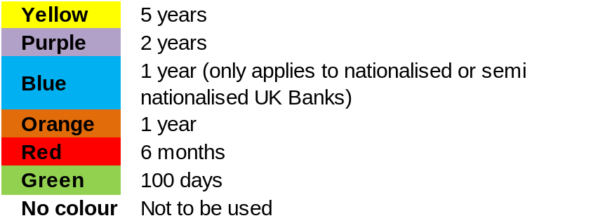

The yellow colour category is for UK Government debt, or its equivalent, money market funds and collateralised deposits where the collateral is UK Government debt.

The Link Asset Services’ creditworthiness service uses a wider array of information other than just primary ratings. Furthermore, by using a risk weighted scoring system, it does not give undue preponderance to just one agency’s ratings.

Typically the minimum credit ratings criteria the Council use will be a Short Term rating (Fitch or equivalents) of F1 and a Long Term rating of A-. There may be occasions when the counterparty ratings from one rating agency are marginally lower than these ratings but may still be used. In these instances consideration will be given to the whole range of ratings available, or other topical market information, to support their use.

All credit ratings will be monitored weekly, and will be checked at the time of placing investments. The Council is alerted to changes to ratings of all three agencies through its use of the Link Asset Services’ creditworthiness service, and has access to the websites of Fitch, Moody’s and Standard & Poor’s.

- if a downgrade results in the counterparty / investment scheme no longer meeting the Council’s minimum criteria, its further use as a new investment will be withdrawn immediately.

- in addition to the use of credit ratings the Council will be advised of information in movements in credit default swap spreads against the iTraxx benchmark and other market data on a daily basis via its Passport website, provided exclusively to it by Link Asset Services. Extreme market movements may result in downgrade of an institution or removal from the Council’s lending list.

Sole reliance will not be placed on the use of this external service. In addition this Council will also use market data and market information, information on any external support for banks to help support its decision making process

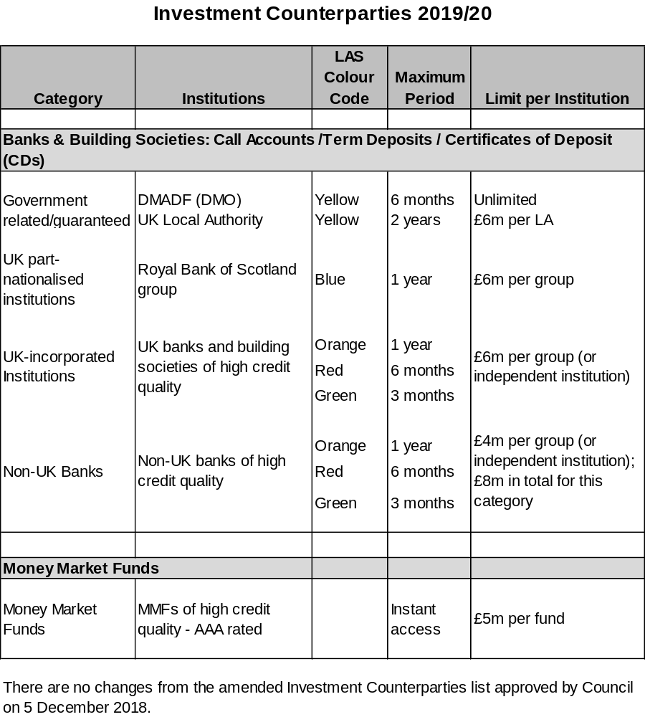

  - Country limits

The Council has determined that, in addition to UK counterparties, it will only use approved counterparties from European Union (EU) countries with a minimum sovereign credit rating of AA- from Fitch. The list of countries that qualify using this credit criteria as at the date of this report are shown below. This list will be added to, or deducted from, by officers should ratings change in accordance with this policy.

Recently the only non-UK counterparty is German bank Landesbank Hessen-Thueringen Girozentrale (Helaba). The Council has invested a maximum of £4m with this counterparty, but could deposit up to £4m in addition with other non-UK counterparties of high credit quality, the maximum sum to be invested with non-UK banks being £8m.

APPROVED COUNTRIES FOR INVESTMENTS – United Kingdom plus the following:

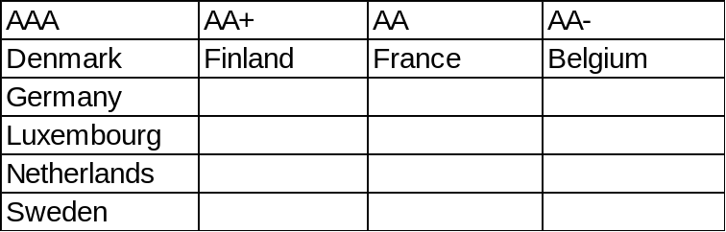

  - Investment strategy

In-house funds
Investments will be made with reference to the core balance and cash flow requirements and the outlook for short-term interest rates (i.e. rates for investments up to 12 months).

Investment returns expectations
Bank Rate is forecast to increase steadily but slowly over the next few years to reach 2.00% by quarter 1 2022. Bank Rate forecasts for financial year ends (March) are:

- 2018/19 0.75% Was 0.75% in 2018/19 Treasury Strategy report
- 2019/20 1.25% Was 1.00%
- 2020/21 1.50% Was 1.25%
- 2021/22 2.00%

The suggested budgeted investment earnings rates for returns on investments placed for periods up to about three months during each financial year are as follows:

 | Now |  | 2017/18 report
2017/18 | 0.40% |  | 0.25%
2018/19 | 0.60% |  | 0.25%
2019/20 | 0.90% |  | 0.50%
2020/21 | 1.25% |  | 0.75%
2021/22 | 1.50% |  | 1.00%
2022/23 | 1.75% |  | 1.50%
2023/24 | 2.00% |  | 1.75%
Later years | 2.75% |  | 2.75%

The overall balance of risks to these forecasts is currently skewed to the upside and are dependent on how strong GDP growth turns out, how quickly inflation pressures rise and how quickly the Brexit negotiations move forward positively.

Investment Treasury Indicator and limit - total principal funds invested for greater than 365 days. These limits are set with regard to the Council’s liquidity requirements and to reduce the need for early sale of an investment, and are based on the availability of funds after each year-end.

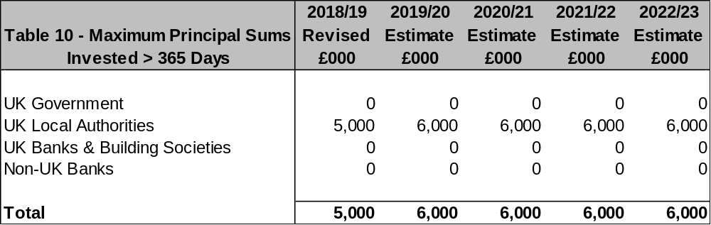

For its cash flow generated balances, the Council will seek to utilise its business reserve instant access and notice accounts, money market funds and short-dated deposits (overnight to 100 days) in order to benefit from the compounding of interest.

  - Investment Risk Benchmarking

This Council will use an investment benchmark to assess the investment performance of its investment portfolio of 7 day LIBID plus 15%.

  - End of Year Investment Report

At the end of the financial year, the Council will report on its investment activity as part of its Annual Treasury Report.

  - Accounting treatment of investments

The accounting treatment may differ from the underlying cash transactions arising from investment decisions made by this Council. To ensure that the Council is protected from any adverse revenue impact, which may arise from these differences, officers will review the accounting implications of new transactions before they are undertaken.

- BACKGROUND DOCUMENTS

CIPFA Treasury Management in the Public Services: Code of Practice & Cross-Sectoral Guidance Notes (December 2017 edition)
CIPFA Treasury Management in the Public Services: Guidance Notes for Local Authorities (July 2018 edition)
CIPFA Prudential Code for Capital Finance in Local Authorities (December 2017 edition)
CIPFA Standards of Professional Practice: Treasury Management
MHCLG Guidance on Local Government Investments
MHCLG Guidance on Minimum Revenue Provision

APPENDIX G1 – Economic Background
APPENDIX G2– Interest Rate Forecasts
APPENDIX G3 – Comparison of Interest Rate Forecasts

APPENDIX G1

ECONOMIC BACKGROUND
Advice from Link Asset Services:
GLOBAL OUTLOOK. World growth has been doing reasonably well, aided by strong growth in the US. However, US growth is likely to fall back in 2019 and, together with weakening economic activity in China and the eurozone, overall world growth is likely to weaken.

Inflation has been weak during 2018 but, at long last, unemployment falling to remarkably low levels in the US and UK has led to an acceleration of wage inflation. The US Fed has therefore increased rates nine times and the Bank of England twice. However, the ECB is unlikely to start raising rates until late in 2019 at the earliest.

KEY RISKS - central bank monetary policy measures
Looking back on nearly ten years since the financial crash of 2008 when liquidity suddenly dried up in financial markets, it can be assessed that central banks’ monetary policy measures to counter the sharp world recession were successful. The key monetary policy measures they used were a combination of lowering central interest rates and flooding financial markets with liquidity, particularly through unconventional means such as quantitative easing (QE), where central banks bought large amounts of central government debt and smaller sums of other debt.

The key issue now is that period of stimulating economic recovery and warding off the threat of deflation, is coming towards its close. A new period is well advanced in the US, and started more recently in the UK, of reversing those measures i.e. by raising central rates and, (for the US), reducing central banks’ holdings of government and other debt. These measures are now required in order to stop the trend of a reduction in spare capacity in the economy and of unemployment falling to such low levels, that the re-emergence of inflation is viewed as a major risk. It is, therefore, crucial that central banks get their timing right and do not cause shocks to market expectations that could destabilise financial markets. In particular, a key risk is that because QE-driven purchases of bonds drove up the price of government debt, and therefore caused a sharp drop in income yields, this also encouraged investors into a search for yield and into investing in riskier assets such as equities. Consequently, prices in both bond and equity markets rose to historically high valuation levels simultaneously. This meant that both asset categories were exposed to the risk of a sharp downward correction and we did, indeed, see a sharp fall in equity values in the last quarter of 2018. It is important, therefore, that central banks only gradually unwind their holdings of bonds in order to prevent destabilising the financial markets. It is also likely that the timeframe for central banks unwinding their holdings of QE debt purchases will be over several years. They need to balance their timing to neither squash economic recovery, by taking too rapid and too strong action, or, conversely, let inflation run away by taking action that was too slow and/or too weak. The potential for central banks to get this timing and strength of action wrong are now key risks. At the time of writing, (early January 2019), financial markets are very concerned that the Fed is being too aggressive with its policy for raising interest rates and is likely to cause a recession in the US economy.

The world economy also needs to adjust to a sharp change in liquidity creation over the last five years where the US has moved from boosting liquidity by QE purchases, to reducing its holdings of debt (currently about $50bn per month). In addition, the European Central Bank ended its QE purchases in December 2018.

UK. The flow of positive economic statistics since the end of the first quarter of 2018 has shown that pessimism was overdone about the poor growth in quarter 1 when adverse weather caused a temporary downward blip. Quarter 1 at 0.1% growth in GDP was followed by a return to 0.4% in quarter 2 and by a strong performance in quarter 3 of +0.6%. However, growth in quarter 4 is expected to weaken significantly.

At their November quarterly Inflation Report meeting, the MPC repeated their well-worn phrase that future Bank Rate increases would be gradual and would rise to a much lower equilibrium rate, (where monetary policy is neither expansionary of contractionary), than before the crash; indeed they gave a figure for this of around 2.5% in ten years’ time, but declined to give a medium term forecast. However, with so much uncertainty around Brexit, they warned that the next move could be up or down, even if there was a disorderly Brexit. While it would be expected that Bank Rate could be cut if there was a significant fall in GDP growth as a result of a disorderly Brexit, so as to provide a stimulus to growth, they warned they could also raise Bank Rate in the same scenario if there was a boost to inflation from a devaluation of sterling, increases in import prices and more expensive goods produced in the UK replacing cheaper goods previously imported, and so on. In addition, the Chancellor could potentially provide fiscal stimulus to support economic growth, though at the cost of increasing the budget deficit above currently projected levels.

It is unlikely that the MPC would increase Bank Rate in February 2019, ahead of the deadline in March for Brexit. Getting parliamentary approval for a Brexit agreement on both sides of the Channel will take well into spring 2019. However, in view of the hawkish stance of the MPC at their November meeting, the next increase in Bank Rate is now forecast to be in May 2019, (on the assumption that a Brexit deal is agreed by both the UK and the EU). The following increases are then forecast to be in February and November 2020 before ending up at 2.0% in February 2022.

Inflation. The Consumer Price Index (CPI) measure of inflation has been falling from a peak of 3.1% in November 2017 to 2.1% in December 2018. In the November Bank of England quarterly Inflation Report, inflation was forecast to still be marginally above its 2% inflation target two years ahead, (at about 2.1%), given a scenario of minimal increases in Bank Rate.

As for the labour market figures in October, unemployment at 4.1% was marginally above a 43 year low of 4% on the Independent Labour Organisation measure. A combination of job vacancies hitting an all-time high, together with negligible growth in total employment numbers, indicates that employers are now having major difficulties filling job vacancies with suitable staff. It was therefore unsurprising that wage inflation picked up to 3.3%, (3 month average regular pay, excluding bonuses). This meant that in real terms, (i.e. wage rates less CPI inflation), earnings are currently growing by about 1.2%, the highest level since 2009. This increase in household spending power is likely to feed through into providing some support to the overall rate of economic growth in the coming months. This tends to confirm that the MPC was right to start on a cautious increase in Bank Rate in August as it views wage inflation in excess of 3% as increasing inflationary pressures within the UK economy.

In the political arena, the Brexit deal put forward by the Conservative minority government was defeated on 15 January. It is unclear at the time of writing, how this situation will move forward. However, our central position is that Prime Minister May’s government will endure, despite various setbacks, along the route to reaching an orderly Brexit though the risks are increasing that it may not be possible to get full agreement by the UK and EU before 29 March 2019, in which case this withdrawal date is likely to be pushed back to a new date. If, however, the UK faces a general election in the next 12 months, this could result in a potential loosening of monetary and fiscal policy and therefore medium to longer dated gilt yields could rise on the expectation of a weak pound and concerns around inflation picking up.

USA. President Trump’s massive easing of fiscal policy is fuelling a (temporary) boost in consumption which has generated an upturn in the rate of strong growth which rose from 2.2% (annualised rate) in quarter 1 to 4.2% in quarter 2 and 3.5%, (3.0% y/y), in quarter 3, but also an upturn in inflationary pressures. The strong growth in employment numbers and the reduction in the unemployment rate to 3.9%, near to a recent 49 year low, has fed through to an upturn in wage inflation which hit 3.2% in November. However, CPI inflation overall fell to 2.2% in November and looks to be on a falling trend to drop below the Fed’s target of 2% during 2019. The Fed has continued on its series of increases in interest rates with another 0.25% increase in December to between 2.25% and 2.50%, this being the fifth increase in 2018 and the ninth in this cycle. However, they did also reduce their forecast for further increases from three to two. This latest increase compounded investor fears that the Fed is over doing the speed and level of increases in rates and that it is going to cause a US recession as a result. There is also much evidence in previous monetary policy cycles of the Fed’s series of increases doing exactly that. Consequently, we have seen stock markets around the world falling under the weight of fears around the Fed’s actions, the trade war between the US and China and an expectation that world growth will slow.

The tariff war between the US and China has been generating a lot of heat during 2018, but it is not expected that the current level of actual action would have much in the way of a significant effect on US or world growth. However, there is a risk of escalation if an agreement is not reached soon between the US and China.

Eurozone. Growth was 0.4% in quarters 1 and 2 but fell back to 0.2% in quarter 3, though this was probably just a temporary dip. In particular, data from Germany has been mixed and it could be negatively impacted by US tariffs on a significant part of its manufacturing exports e.g. cars. For that reason, although growth is still expected to be in the region of nearly 2% for 2018, the horizon is less clear than it seemed just a short while ago. Having halved its quantitative easing purchases of debt in October 2018 to €15bn per month, the European Central Bank ended all further purchases in December 2018. The ECB is forecasting inflation to be a little below its 2% top limit through the next three years so it may find it difficult to warrant a start on raising rates by the end of 2019 if the growth rate of the EU economy is on a weakening trend.

China. Economic growth has been weakening over successive years, despite repeated rounds of central bank stimulus; medium term risks are increasing. Major progress still needs to be made to eliminate excess industrial capacity and the stock of unsold property, and to address the level of non-performing loans in the banking and credit systems. Progress has been made in reducing the rate of credit creation, particularly from the shadow banking sector, which is feeding through into lower economic growth. There are concerns that official economic statistics are inflating the published rate of growth.

Japan - has been struggling to stimulate consistent significant GDP growth and to get inflation up to its target of 2%, despite huge monetary and fiscal stimulus. It is also making little progress on fundamental reform of the economy. It is likely that loose monetary policy will endure for some years yet to try to stimulate growth and modest inflation.

Emerging countries. Argentina and Turkey are currently experiencing major headwinds and are facing challenges in external financing requirements well in excess of their reserves of foreign exchange. However, these countries are small in terms of the overall world economy, (around 1% each), so the fallout from the expected recessions in these countries will be minimal.
APPENDIX G2

INTEREST RATE FORECASTS

The interest rate forecasts provided by Link Asset Services are predicated on an assumption of an agreement being reached on Brexit between the UK and the EU. On this basis, while GDP growth is likely to be subdued in 2019 due to all the uncertainties around Brexit depressing consumer and business confidence, an agreement is likely to lead to a boost to the rate of growth in 2020 which could, in turn, increase inflationary pressures in the economy and so cause the Bank of England to resume a series of gentle increases in Bank Rate. Just how fast, and how far, those increases will occur and rise to, will be data dependent. The forecasts in this report assume a modest recovery in the rate and timing of stronger growth and in the corresponding response by the Bank in raising rates.

- In the event of an orderly non-agreement exit, it is likely that the Bank of England would take action to cut Bank Rate from 0.75% in order to help economic growth deal with the adverse effects of this situation. This is also likely to cause short to medium term gilt yields to fall.
- If there was a disorderly Brexit, then any cut in Bank Rate would be likely to last for a longer period and also depress short and medium gilt yields correspondingly. It is also possible that the government could act to protect economic growth by implementing fiscal stimulus.

However, there would appear to be a majority consensus in the Commons against any form of non-agreement exit so the chance of this occurring has now substantially diminished.

The balance of risks to the UK

- The overall balance of risks to economic growth in the UK is probably neutral.
- The balance of risks to increases in Bank Rate and shorter term PWLB rates, are probably also even and are broadly dependent on how strong GDP growth turns out, how slowly inflation pressures subside, and how quickly the Brexit negotiations move forward positively.

One risk that is both an upside and downside risk, is that all central banks are now working in very different economic conditions than before the 2008 financial crash as there has been a major increase in consumer and other debt due to the exceptionally low levels of borrowing rates that have prevailed for ten years since 2008. This means that the neutral rate of interest in an economy, (i.e. the rate that is neither expansionary nor deflationary), is difficult to determine definitively in this new environment, although central banks have made statements that they expect it to be much lower than before 2008. Central banks could therefore either over or under do increases in central interest rates.

Downside risks to current forecasts for UK gilt yields and PWLB rates currently include:

- Brexit – if it were to cause significant economic disruption and a major downturn in the rate of growth.

- Bank of England monetary policy takes action too quickly, or too far, over the next three years to raise Bank Rate and causes UK economic growth, and increases in inflation, to be weaker than we currently anticipate.

- A resurgence of the eurozone sovereign debt crisis, possibly in Italy, due to its high level of government debt, low rate of economic growth and vulnerable banking system, and due to the election in March of a government which has made a lot of anti-austerity noise. The EU rejected the initial proposed Italian budget and demanded cuts in government spending which the Italian government initially refused. However, a fudge was subsequently agreed, but only by delaying the planned increases in expenditure to a later year. This can has therefore only been kicked down the road to a later time. The rating agencies have started on downgrading Italian debt to one notch above junk level. If Italian debt were to fall below investment grade, many investors would be unable to hold it. Unsurprisingly, investors are becoming increasingly concerned by the words and actions of the Italian government and consequently, Italian bond yields have risen – at a time when the government faces having to refinance large amounts of debt maturing in 2019.

- Weak capitalisation of some European banks. Italian banks are particularly vulnerable; one factor is that they hold a high level of Italian government debt - debt which is falling in value. This is therefore undermining their capital ratios and raises the question of whether they will need to raise fresh capital to plug the gap.

- German minority government. In the German general election of September 2017, Angela Merkel’s CDU party was left in a vulnerable minority position dependent on the fractious support of the SPD party, as a result of the rise in popularity of the anti-immigration AfD party. Then in October 2018, the results of the Bavarian and Hesse state elections radically undermined the SPD party and showed a sharp fall in support for the CDU. As a result, the SPD is reviewing whether it can continue to support a coalition that is so damaging to its electoral popularity. After the result of the Hesse state election, Angela Merkel announced that she would not stand for re-election as CDU party leader at her party’s convention in December 2018, (a new party leader has now been elected). However, this makes little practical difference as she is still expected to aim to continue for now as the Chancellor. However, there are five more state elections coming up in 2019 and EU parliamentary elections in May/June; these could result in a further loss of electoral support for both the CDU and SPD which could also undermine her leadership.

- Other minority eurozone governments. Spain, Portugal, Ireland, the Netherlands and Belgium all have vulnerable minority governments dependent on coalitions which could prove fragile. Sweden is also struggling to form a government due to the anti-immigration party holding the balance of power, and which no other party is willing to form a coalition with. The Belgian coalition collapsed in December 2018 but a minority caretaker government has been appointed until the May EU wide general elections.

- Austria, the Czech Republic and Hungary now form a strongly anti-immigration bloc within the EU while Italy, in 2018, also elected a strongly anti-immigration government. Elections to the EU parliament are due in May/June 2019.

- Further increases in interest rates in the US could spark a sudden flight of investment funds from more risky assets e.g. shares, into bonds yielding a much improved yield. Throughout the last quarter of 2018, we saw sharp falls in equity markets interspersed with occasional partial rallies. Emerging countries which have borrowed heavily in dollar denominated debt, could be particularly exposed to this risk of an investor flight to safe havens e.g. UK gilts.

- There are concerns around the level of US corporate debt which has swollen massively during the period of low borrowing rates in order to finance mergers and acquisitions. This has resulted in the debt of many large corporations being downgraded to a BBB credit rating, close to junk status. Indeed, 48% of total investment grade corporate debt is now rated at BBB. If such corporations fail to generate profits and cash flow to reduce their debt levels as expected, this could tip their debt into junk ratings which will increase their cost of financing and further negatively impact profits and cash flow.

- Geopolitical risks, especially North Korea, but also in Europe and the Middle East, which could lead to increasing safe haven flows.

Upside risks to current forecasts for UK gilt yields and PWLB rates

- Brexit – if both sides were to agree by 29 March a compromise that quickly removed all threats of economic and political disruption and so led to an early boost to UK economic growth.

- The Fed causing a sudden shock in financial markets through misjudging the pace and strength of increases in its Fed Funds Rate and in the pace and strength of reversal of QE, which then leads to a fundamental reassessment by investors of the relative risks of holding bonds, as opposed to equities. This could lead to a major flight from bonds to equities and a sharp increase in bond yields in the US, which could then spill over into impacting bond yields around the world.

- The Bank of England is too slow in its pace and strength of increases in Bank Rate and, therefore, allows inflation pressures to build up too strongly within the UK economy, which then necessitates a later rapid series of increases in Bank Rate faster than we currently expect.

- UK inflation, whether domestically generated or imported, returning to sustained significantly higher levels causing an increase in the inflation premium inherent to gilt yields.

APPENDIX C

Appendix G3
Comparison of Interest Rate Forecasts – Treasury Strategy 2018/19 – 2022/23 (Feb 2018), and Treasury Strategy 2019/20 – 2022/23 (Jan 2019)

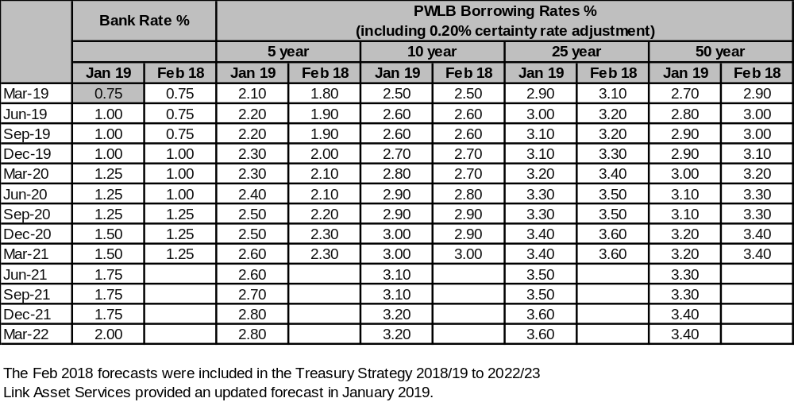

Appendix H



Equality Impact Assessment

Introduction

An Equality Impact Assessment (EIA) is required to ensure that equality is placed at the centre of policy development and review, as well as service delivery. The purpose of this EIA is to systematically analyse the likely impact of a service, policy or proposals on different community groups, and how the needs of such groups have been taken into account in developing those proposals.

The EIA can anticipate and recommend ways to avoid any discriminatory or negative consequences for a particular group, on the grounds of any protected characteristic. It provides the opportunity to demonstrate the potential benefits for equality target groups arising from a proposed policy or project.

The need for an EIA stems from the general duty placed on public authorities to eliminate unlawful discrimination in carrying out functions, and promote equality of opportunity. This is outlined in the Equality Act 2010, with specific public sector duties in place from April 2011.

1. Name of Policy or Service (existing or proposed)
Budget and Medium-Term Financial Strategy 2019/23

2. Responsible Manager
Tim Povall – Deputy Chief Executive – Resources and Transformation – S151 Officer
3. Date EIA completed | Review date
23/01/19 | January 2020
4. Description and aims of policy / service (including relevance to equalities)
To bring together the Council’s vision, priorities, objectives, key actions and measures for the Council, which drives the budget and performance management framework.

5. Who are the stakeholders?
- Cabinet
- Scrutiny
- Councillors
- Leadership Team
- Employees
- External partners
- Residents
- Businesses
- External Audit

6. What outcomes do we want to achieve?
That the Council agrees its 2019/20 Budget and Medium Term Financial Strategy for the next 4 years. This is the financial plan for the Council which is aligned to the Corporate Plan and the resources required to deliver its ambitions and services to the residents.

7. How will performance be measured?
- By the Council’s Leadership Team and Extended Leadership Team every quarter
- Budget monitoring reports to Governance/Cabinet in Quarters 2, 3 and 4.

8. Brief summary of research and background data
- Existing research on the demographics of the Borough
- Stakeholder feedback – residents, partners, businesses
- Input from the all members at extended Member Learning Hours
- Input from Scrutiny Committee
- Input from Cabinet

9. Methods and outcome of consultation
- Consultation with residents via Residents’ Survey undertaken in February 2019
- Business event January 2019.

10. Results of initial screening
The following questions have been considered in order to evaluate the various equality groups:-

Age – Is there any concern that these proposals could cause differential impact on the grounds of age? All age groups considered.

Disability – Is there any concern that these proposals could cause differential impact on the grounds of disability? Disability is recognised under the Equality Act as ‘a physical or mental impairment which has a substantial and long term effect on a person’s ability to carry out normal day to day activities.’ No Impact

Gender Reassignment – Is there any concern that these proposals could cause differential impact on the grounds of gender reassignment? The Equality Act recognises this where a person is proposing to undergo, is undergoing, or has undergone a process (or part of a process) for changing sex. – No impact

Marriage / Civil Partnership – Is there any concern that these proposals could cause differential impact on the grounds of marriage or civil partnership? Under the Equality Act, no such protection exists for single or unmarried people. – No impact

Pregnancy / Maternity – Is there any concern that these proposals could cause differential impact on the grounds of pregnancy or maternity? No impact

Race – Is there any concern that these proposals could cause differential impact on the grounds of race? Race is recognised under the Equality Act as a person’s skin colour, nationality or ethnic origin. No impact

Gender – Is there any concern that these proposals could cause differential impact on the grounds of gender? Including men, women and transgender people. No impact

Sexual Orientation – Is there any concern that these proposals could cause differential impact on the grounds of sexuality? Including heterosexual, gay, lesbian and bisexual people. No impact

Religion or belief – Is there any concern that these proposals could cause differential impact on the grounds of religion or faith? All faiths recognised in the European Convention of Human Rights are included. No impact

A commentary has been provided for each policy where appropriate
11. Decisions and / or recommendations (including supporting rationale)
The Corporate Plan, Budget and Medium Term Financial Strategy have been developed specifically to address the needs of the Borough and there is no adverse impact on any particular group or groups. As projects identified in the Corporate Plan, Budget and MTFS are developed further, equality impact assessments will be undertaken at that time.

12. Is an Equality Action Plan required?
No.

